

**FYP FINAL REPORT**

**2019/2020**

**AUTOMATIC SHOPPING CART**

**(CARTIGO)**

**GROUP MEMBERS:**

**AHMED ALI RAZA (9718)**

**BILAL AHMED (14444)**

**HAMZA ARIF (14446)**

**SUPERVISOR:**

**RIDAH FATIMA MUDASSIR.**

**COORDINATOR:**

**DR AARIJ MEHMOOD HASSAAN.**

**Chapter 1:**

**Introduction**

1. **Aim & Objectives**

The aim and objectives are to develop RFID based billing system for supermarkets in order to make billing process convenient and easy. Implementing an Automatic shopping cart using RFID technology that will be saving time of customers and improving purchasing. In this RFID card is utilized by the RFID reader in the shopping cart when the customer wants to add product the cost of the product will be shown and the total amount of bill will display on the LCD, when the customer wants to remove the product from the Cart, you need to take product out from the Cart, the amount of that product by scanning it again and gets deducted from the total amount. After customer finished shopping, the customer will press send button on the hardware device and the bill will be generated in the database which could be taken by providing the Cart ID trolley number. The main purpose of this system is to make it effectively adaptable for helping the customers, time will be saved at the billing counters avoiding the long waiting queues.

1. **Relevance of domain**

Today shopping is becoming a time consuming, hectic activity in cities. There are long lines in marts on weekend/events in big cities. Therefore, at different marts because of this, after shopping the customer reach billing counter for bill but since using bar code for adding product and calculating bill that is very time consuming and that increases the waiting queues for Bill. The ultimate goal is to develop a system consisting of a hardware device with a software that can be used in super marts to resolve the long queues at billing counter using RFID Technology using in the super marts with single and multiple cash counters.

1. **Research Question:**

**Q: How do you like our designed Project Trolley?**

Good designed, yes brilliant idea, a very good layout but still equipment attached is too big, it depends on its function, if this place is just to scan you can better place under trolley. Is that good innovative, it’s cool.

**Q: In Your Opinion where in the Trolley we should Fixed the Hardware?**

Handle

Front side

Top (at handle)

**Q: Do you Want anything to be improved in our Hardware you Can share your Views With us we will try to Improve?**

Go for touchscreen technology like iPad

Hide the circuit, improve hardware design means look

Hardware looks good but either it should be compact to place in front otherwise it must be installed down as prototype it's fine, but for commercial purpose you need more durable and neater. Good work, so far the design is good, hardware should be small physically You can wrap your hardware well and fit it like it is the part of the trolley so If the system under the basket than the system surely safe, it is enough to meet requirement

**Q: Do you Think that our Project will have any Impact in Our Super marts and Will Reduce Time at Billing Counter?**

38.9%

61.1%

**Q: Do you think In Supermarts like Chase up, Metro Cash & Carry, Imtiaz super store, Shazz, Bin Hashim, Bin Safeer and others etc. they took more time in Billing counter?**

No=11.1%

Yes=83.3%

**Q: Do you think In Super marts Our project will work to reduce time in Billing counter?**

Yes=94.4%

**Q: In Which Supermarket you would Recommend for Using Our Project (CARTIGO) will be Useful in Reducing Time? Name & Reason?**

Carrefour, Make more reliable this product. Imtiaz super market and chassio, Imtiaz due to customer inflow, Big ones. In large supermarket like imtiaz there are many crowds came every day, Imtiaz, Metro, chase etc.

**Q: How much Percentage (%) In Supermart Using Our Project (CARTIGO) will be Useful in Reducing TIme?**

20% to 30%

40% to 50%

60% to 70%

1 (5.6%)

4 (22.2%)

13 (72.2%)

1. **Report Structure**

**Chapter 1:**

* Introduction.
* Relevance of Domain.
* Research Questions.

**Chapter 2:**

* Technology Background.
* Detail background of the technology
* Discuss the problem domain with historical background
* similar solutions and compare with yours
* Summary of 4-5 research papers related to the technology.

**Chapter 3;   
 Requirements & Methodology**

* What logic, Constraints, platform and strategy you would use to implement requirements?
* Justify why you would use these strategies or platform or language?
* Project Flow Diagram.
* Security Alarm (Project Flow Diagram).
* Project Architecture
* Features
  + Functional requirements.
  + Non-Functional requirements.

**Chapter 4;**

**Project Plan & Initial Design**

* Gantt Chart.
* Diagrams
* Use Case Diagram,
* Activity Diagram
* Class Diagram
* Conceptual ERD Diagram,
* Add Prototype (blueprint) or initial design of your UI, which was made before starting the project.

**Chapter 5;**

**Project Design & Development**

* **Design**
  + Front End Design:
* Color Theme
* Logo
* Template
* Screenshots of the User Interface with Description.
  + Backend Design: this includes physical ERD of the database designed directly using DBMS after implementing the conceptual design. It must have column types and sizes.
* **Development**
  + **Discuss different stages of development, add code or any important logic you want to discuss, discuss code you used to design layouts and implement logic.**
* Libraries
* Languages
* Platform used to develop the project,
  + **Add important database queries, update database logics.**
* Add/delete/update/bill ID/save total
* search products /search bills
  + **Screenshots of a sample run of your project**

**Chapter 6;**

1. **Test Plans**

* Purpose
* Test Objectives
* Scope

1. **Testing Methodologies**

* Black box testing
* White box testing

1. **Level of Testing**

* Unit testing
* Modules tested
* Integration testing
* Functional testing
* Regression testing
* Hardware testing
* Performance testing
* Usability testing
* GUI testing
* Compatibility testing
* System testing

1. **Test Cases Factors**

* Test entry/exit criteria
* Test deliverables
* Test suspension/resumption criteria
* Test environmental/staffing/training needs

1. **Test Cases**

**Chapter 7;**

* **Conclusion**
* **Future Work**

============================================

**---------------------------------------------------------------------------  
Chapter 2;   
Technology Background**  
**---------------------------------------------------------------------------**

**Hardware Specification:**

**Arduino-Kit:**

This is an Arduino pro mini AT mega328 5V 16M compatible board. A microcontroller board based on AT mega168 used as Arduino in hardware.

**Node MCU:**

NodeMCU is an open source firmware, development kit that helps you build prototype or build IoT product. It includes firmware which runs on the ESP8266 Wi-Fi SoC from Espressif Systems, and hardware which is based on the ESP-12 module. It is based on the eLua project, and built on the Espressif Non-OS SDK for ESP8266.

**RFID Reader:** A radio frequency identification **reader** (**RFID reader**) is a device used to readinformation from an RFID tag associated with object, which is used to read tags no# on objects. RFID reader is like transceiver and receiver with the use of radio frequency signals.

**RFID Tags:** Tags are important part of RFID system, because they store the information of the objectbeing tracked. Object information, which has UID is stored in the memory of tags and is accessed via the radio signal of RFID readers. There are different types of Tags.

* Active
* Semi-passive
* Passive

Passive RFID Tags have no internal power supply since we are using passive tags. Passive tags signal by backscattering method from reader. Passive tags have practical read distances ranging from about 11 cm up to 10 meters.

**Passive Tags (Ranges):**

•LF: 125 kHz – 134.2 kHz,

•HF: 13.56 MHz,

•UHF: 860 MHz – 960 MHz,

•SHF: 2.45 GHz.

|  |  |  |  |  |
| --- | --- | --- | --- | --- |
| **Frequency** | **LF** | **HF** | **UHF** | **Microwave** |
| **Ranges** | **125 KHz** | **13.56 MHz** | **868-915 MHz** | **2.45 GHz &** |
|  |  |  |  | **5.8 GHz** |
| **Read Range** | Shortest 1”-12” | Short 2”-24” | Medium 1’-10’ | Longest 1’-15’ |
| **(Passive Tags)** |  |  |  |  |
| **Data Rate** | Slower | Moderate | Fast | Faster |
|  |  |  |  |  |
| **Ability to read** | Better | Moderate | Poor | Worse |
| **near metal or** |  |  |  |  |
| **wet surfaces** |  |  |  |  |

**Advantages of Passive Tags:**

* Size is Optimized
* Lesser Cost
* More Flexibility
* Ability of Reading from Longer Range
* Lifelong capability.
  1. **Discuss the problem domain with historical background.**

In Pakistan there is no such system is being implemented yet, but research on this idea has been done. This is a new innovative idea that brings the relief to the people by saving time. we are using RFID reader with Arduino and every product have RFID card number used for product identification which is connected to the Centralized database which will calculate the bill of the customer bill with Cart ID give to the trolley when they reached the counter. The system performance is increased and speed but the weaknesses is about the hardware to get damaged and not work.

The bar-code scanning system for billing which is most time consuming. So we are presenting the solution of billing system, replacing it with automatic billing by scanning the product in trolley since every product has its own identity of RFID card number, RFID tags have Unique products ID that will help to increase performance.

* 1. **All similar solutions and compare with your solution**.

**Literature Review:**

* Smart Shopping Trolley Using RFID (International Engineering Research Journal (IERJ) Volume 2 Issue 3 Page 1418-1421, 2016, ISSN 2395-1621).
* SMART SHOPPING TROLLEY USING RFID (International Journal of Pure and Applied Mathematics Volume 118 No. 20 2018, 3783-3786).
* A Review on Automatic Billing Trolley (International Journal of Research in Advent Technology (IJRAT) (E-ISSN: 2321-9637) Special Issue National Conference “CONVERGENCE 2017”, 09th April 2017).
* RFID Based Smart Trolley for Automatic Billing System (Volume 7 Issue No.6 , ISSN XXXX XXXX © 2017 IJESC).
* Design and Implementation of a Smart Shopping Cart by RFID Technology (by Nemalidinne Sai Megana A thesis submitted in partial fulfillment of the requirements for the degree of Master of Engineering in Microelectronics and Embedded Systems).
* RFID BASED SMART TROLLEY FOR SUPERMARKET AUTOMATION (International Research Journal of Engineering and Technology (IRJET) e-ISSN: 2395-0056 Volume: 04 Issue: 07 | July 2017 www.irjet.net p-ISSN: 2395-0072).
* A SMART TROLLEY WITH RFID IMPLEMENTATION: A SURVEY AMONG CUSTOMERS (VOL. 12, NO. 4, FEBRUARY 2017 ISSN 1819-6608, ARPN Journal of Engineering and Applied Sciences ©2006-2017 Asian Research Publishing Network (ARPN). All rights reserved. www.arpnjournals.com).
* LIFI BASED AUTOMATED SMART TROLLEY USING RFID (International Journal of Scientific & Engineering Research, Volume 7, Issue 3, March-2016, 1026 ISSN 2229-5518 IJSER © 2016 http://www.ijser.org).
* Developing a Multitasking Shopping Trolley Based on RFID Technology (International Journal of Soft Computing and Engineering (IJSCE) ISSN: 2231-2307, Volume-3, Issue-6, January 2014).
* Smart Shopping Trolley using RFID (Volume 8 Issue No.3, ISSN XXXX XXXX © 2018 IJESC).
* SMART SHOPPING TROLLEY FOR SUPERMARKETS USING RECHARGEABLE SMART CARD (International Journal of Scientific & Engineering Research Volume 8, Issue 7, July-2017 ISSN 2229-5518)
* SMART SHOPPING TROLLEY USING RFID (International Journal of Pure and Applied Mathematics Volume 118 No. 20 2018, 3783-3786 ISSN: 1314-3395 (on-line version) URL: http://www.ijpam.eu).
  1. **Summary of 4-5 research papers related to the technology.**

**Literature Review:**

**(1) Smart Shopping System Using RFID:**

International Engineering Research Journal (IERJ) Volume 2 Issue 3 Page 1418 1421, 2016, ISSN 2395-1621.

**Result and Analysis:**

Trolley utility will be for commercial use first of its kind. 2. With the help of appropriate sensors like RFID Tags, this device records the data of the various products. 3. This recorded data provides the shop owner through the machine with detailed analysis of the customer's shopping and their preferences; it is possible to obtain the same.

**FUTURE SCOPE:**

The proposed Smart Shopping Trolley System aims to assist in-person shopping which will minimize the considerable amount of time spent in shopping as well as the time needed to easily locate the desired product. The customer simply has to type the product name he / she wants to search on the Android device and the cart will automatically guide him / her to the locations of the products.

**(2) SMART SHOPPING TROLLEY USING Smart Phone and Arduino:**

Reference: Bedi HS, Goyal N, Kumar S, Gupta A (2017) Smart Trolley using Smart Phone and Arduino. J Electr Electron Syst 6: 223. doi: 10.4172/23320796.1000223.

**CONCLUSION:**

In Smart Trolley System, the customers now don't need to wait in the queue and wait for their turn to check the product products. Especially during the weekends or festivals season, waiting in the queue is not time-waste. The customer only has to pay at the billing counter and only those customers who have a membership card can use the smart trolley where RFID is used.

**Future Scope:**

We will refresh the product element information in the trolley memory unit from time to time. We take the help of the Internet of Things and some software which will regularly update all details. We will also produce trolleys with the aid of optical sensors, motors and motor drivers in such a way that they will obey the customer who purchases products and keep them safe.

**(3) RFID Based Smart Trolley for Automatic Billing System:**

International Research Journal of Engineering and Technology (IRJET)e-ISSN: 2395-0056 Volume: 04 Issue: 07 | July -2017, www.irjet.net, p-ISSN: 2395-0072.

**CONCLUSION:**

Shopping will benefit from the proposed system for use in supermarkets, as it would make shopping easier. Now, in order to pay the bill, the customer does not need to stand in a queue. The system does automatic billing. This paper's idea was drawn from large queues at the shopping mall and the inconvenience it creates for the customer. This new billing system is quick as the details of the single product are recorded as it fell into the trolley. Working on this product it was noted that RFID technology and Zigbee in the near future are very extensive applications. Also, RFID is better and faster than reading barcode because the later is compact and reliable on line of sight, which is not the case with RFID technology. Zigbee is the wireless network which connects the costumer with the retailer and is very secure with long operating range. This smart shopping device will absolutely alter the way you shop. The most commonly-used RFID and Zigbee technology would definitely find some commercial use. In addition, this smart trolley will be very useful as it will reduce the number of salesmen and billing counters as well as save time for both the customer and the shopper.

**(4) Design and Implementation of a Smart Shopping Cart by RFID Technology:**

Smart shopping trolley application creates an automated central billing system in malls by using the ZigBee.

**RESULT:**

The proposal ultimately resulted in an effective result where RFID technology replaced barcode due to its drawback where barcode requires the line of sight and should be placed at its exact boundary while scanning, but RFID's only constraint is its distance coverage. RFID tags are longer lasting than barcodes that are harmful due to temperature, humidity, physical tear, etc. This ensures fast and accurate scanning process. Fig.3 shows system hardware connection and an LCD bill display. The Arduino uno digital input pins 9, 10, 11, 12, 13 are connected to the RST, SDA, MOSI, MOSO, SCK of the 3.3V VCC reader. The 5V LCD with I2C backpack includes SDA and SCL connected to Arduino’s A4 and A5 respectively. Zigbee is used to send customer and counter product information. Zigbee S2C's TX-out and RX-in are connected for serial communication to the microcontroller pin 2, 3. One of the S2C radios is configured as a coordinator for communication and another as a router. Zigbee is running 3.3V.

**CONCLUSION:**

Shopping will benefit from the proposed system for use in supermarkets, as it would make shopping easier. Now, in order to pay the bill, the customer does not need to stand in a queue. The system makes automatic invoicing. This paper's idea was drawn from large queues at the shopping mall and the inconvenience it creates for the customer. This new billing system is quick as the details of the single product are recorded as it fell into the trolley. It has been noted that RFID technology and Zigbee are very extensive applications in the near future. Also, RFID is better and faster than reading barcode because the later is compact and reliable on line of sight, which is not the case with RFID technology. Zigbee is the wireless network that connects the costumer to the retailer and is extremely secure with a long operating range. A smart shopping device will fully change the way shopping takes place. The most widely used RFID and Zigbee technologies will definitely find some use commercially. Moreover, this smart trolley will be very useful as it will reduce the number of salesmen and billing counters as well as save time for both consumers and shopper.

**(5) LIFI BASED AUTOMATED SMART TROLLEY USING RFID:**

International Journal of Scientific & Engineering Research, Volume 7, Issue 3, March-2016,1026 ISSN 2229-5518

**FUTURE SCOPE:**

The LIFI technology can be used in vehicle communication in future. The LCD can be fitted with a shopping market interface that allows consumers to receive accurate information on the items in different aisles. This improves user friendliness. During a shopping trip the smart trolley may interact with customers. For example, passing discount vouchers according to where they are in the supermarket. The trolley movement can be made automatically with the help of different sensors. There's no need to pull this big trolley in this direction.

**CONCLUSION:**

In the developed prototype model, the intended goal is successfully achieved. The software built is user-friendly and needs no specific training. It has the effective use of LIFI technology and can minimize the queues in the mall by the smart trolley. So, you can save the time of that client.

**-----------------------------------------------------------------  
Chapter 3;   
Requirements & Methodology**

**----------------------------------------------------------------------------**

**PROJECT DESCRIPTION:**

Our Idea is of making an automatic smart cart, assigning RFID tags to the products and RFID reader and with LCD with ESP8266(Wifi-Module) in the purchasing cart. the Customer can see the Cost of each product, number of products and total amount. the quantity of items will be printed in bill and if the customer has to change his mind then just press the Remove button and scan the products you want to remove; the product price and amount will be reduced from Total Amount. The Total Bill amount will be displayed on LCD in the cart. the customer sends the data by clicking on the Send button when completed shopping with the associated ID and from which the Customers bill will get printed, this will save customer time at the billing counter, this will save money and time. the smart cart will make shopping easier for the customers with improvising comfort for customers.

* What logic, constraints, platform and strategy you would use to implement requirements given below and Justify why you would use these strategies or platform or language?
* The logic behind all the project is to reduce long queues that cause headaches which could be possible using arduino with rfid reader with node mcu used in hardware in which product is scanned and stored in node mcu and then send the data to CBU which web form through xml /json and the bill generated at the billing counter must be verified and checked the cashier can check the product information at that time and for every customer there is s unique bill ID which we will use for customer verification, once the customer pays he received card from cashier to exit which will be authenticated card if unauthenticated card scan against rfid reader od security pass the alarm will be on this is generally the idea of the project we know that there are and have many limitation and risk is this project but until you don’t catch the problem you could not found solutions and for that you have to dive in the sea and check and we have solved some problems and in future more people will extend it to the next level.
* We chose this platform or language because we are already diving in an ocean and to dive into another ocean of language would be most difficult for us and since everyone cannot have knowledge of everything you gather is in bits and pieces and which sums up knowledge and since we have knowledge that it could be built in lots of other language and since businessman find ease of doing business places, from that we have chosen from all difficulties that ease of using known language is very useful but I know it is helpful but have constraints.

**Software requirements:**

**Programming Languages:**

1. Embedded C
2. PHP, CSS, JavaScript, HTML
3. MYSQL

**Platform:**

* Sublime Text editor (software)
* MySQL (PhpMyAdmin)(database)
* **Project Flow Diagram :**.

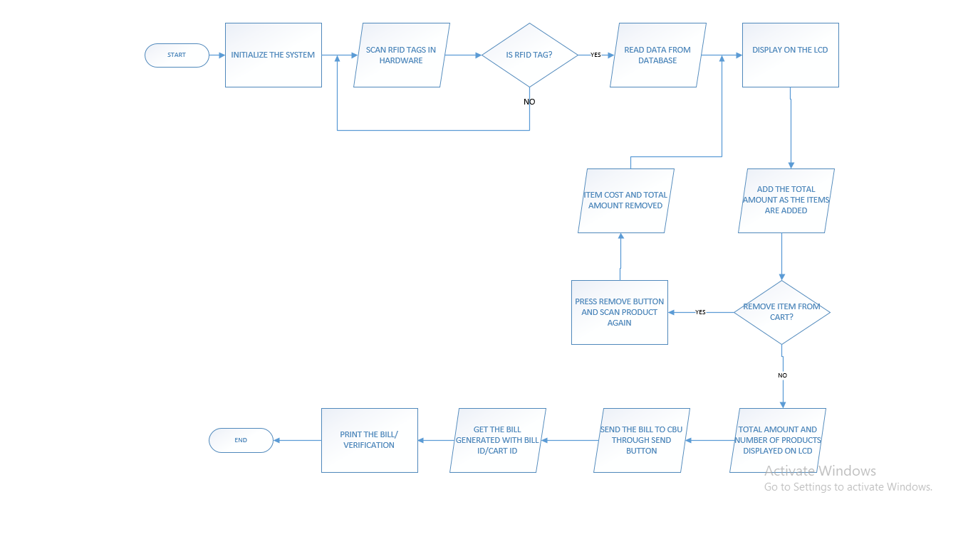

**SECURITY ALARM DIAGRAM :**

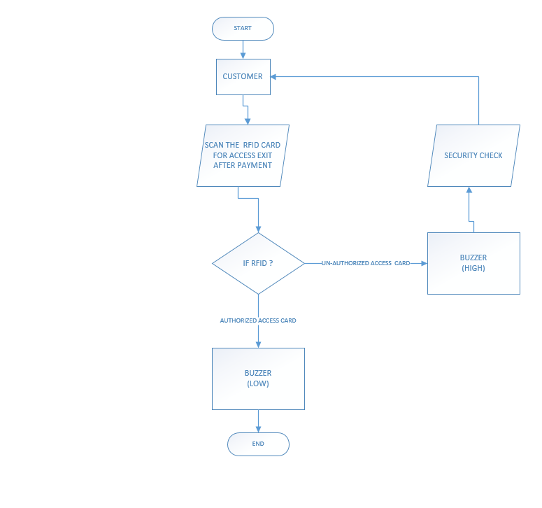

**PROJECT ARCHITECTURE:**

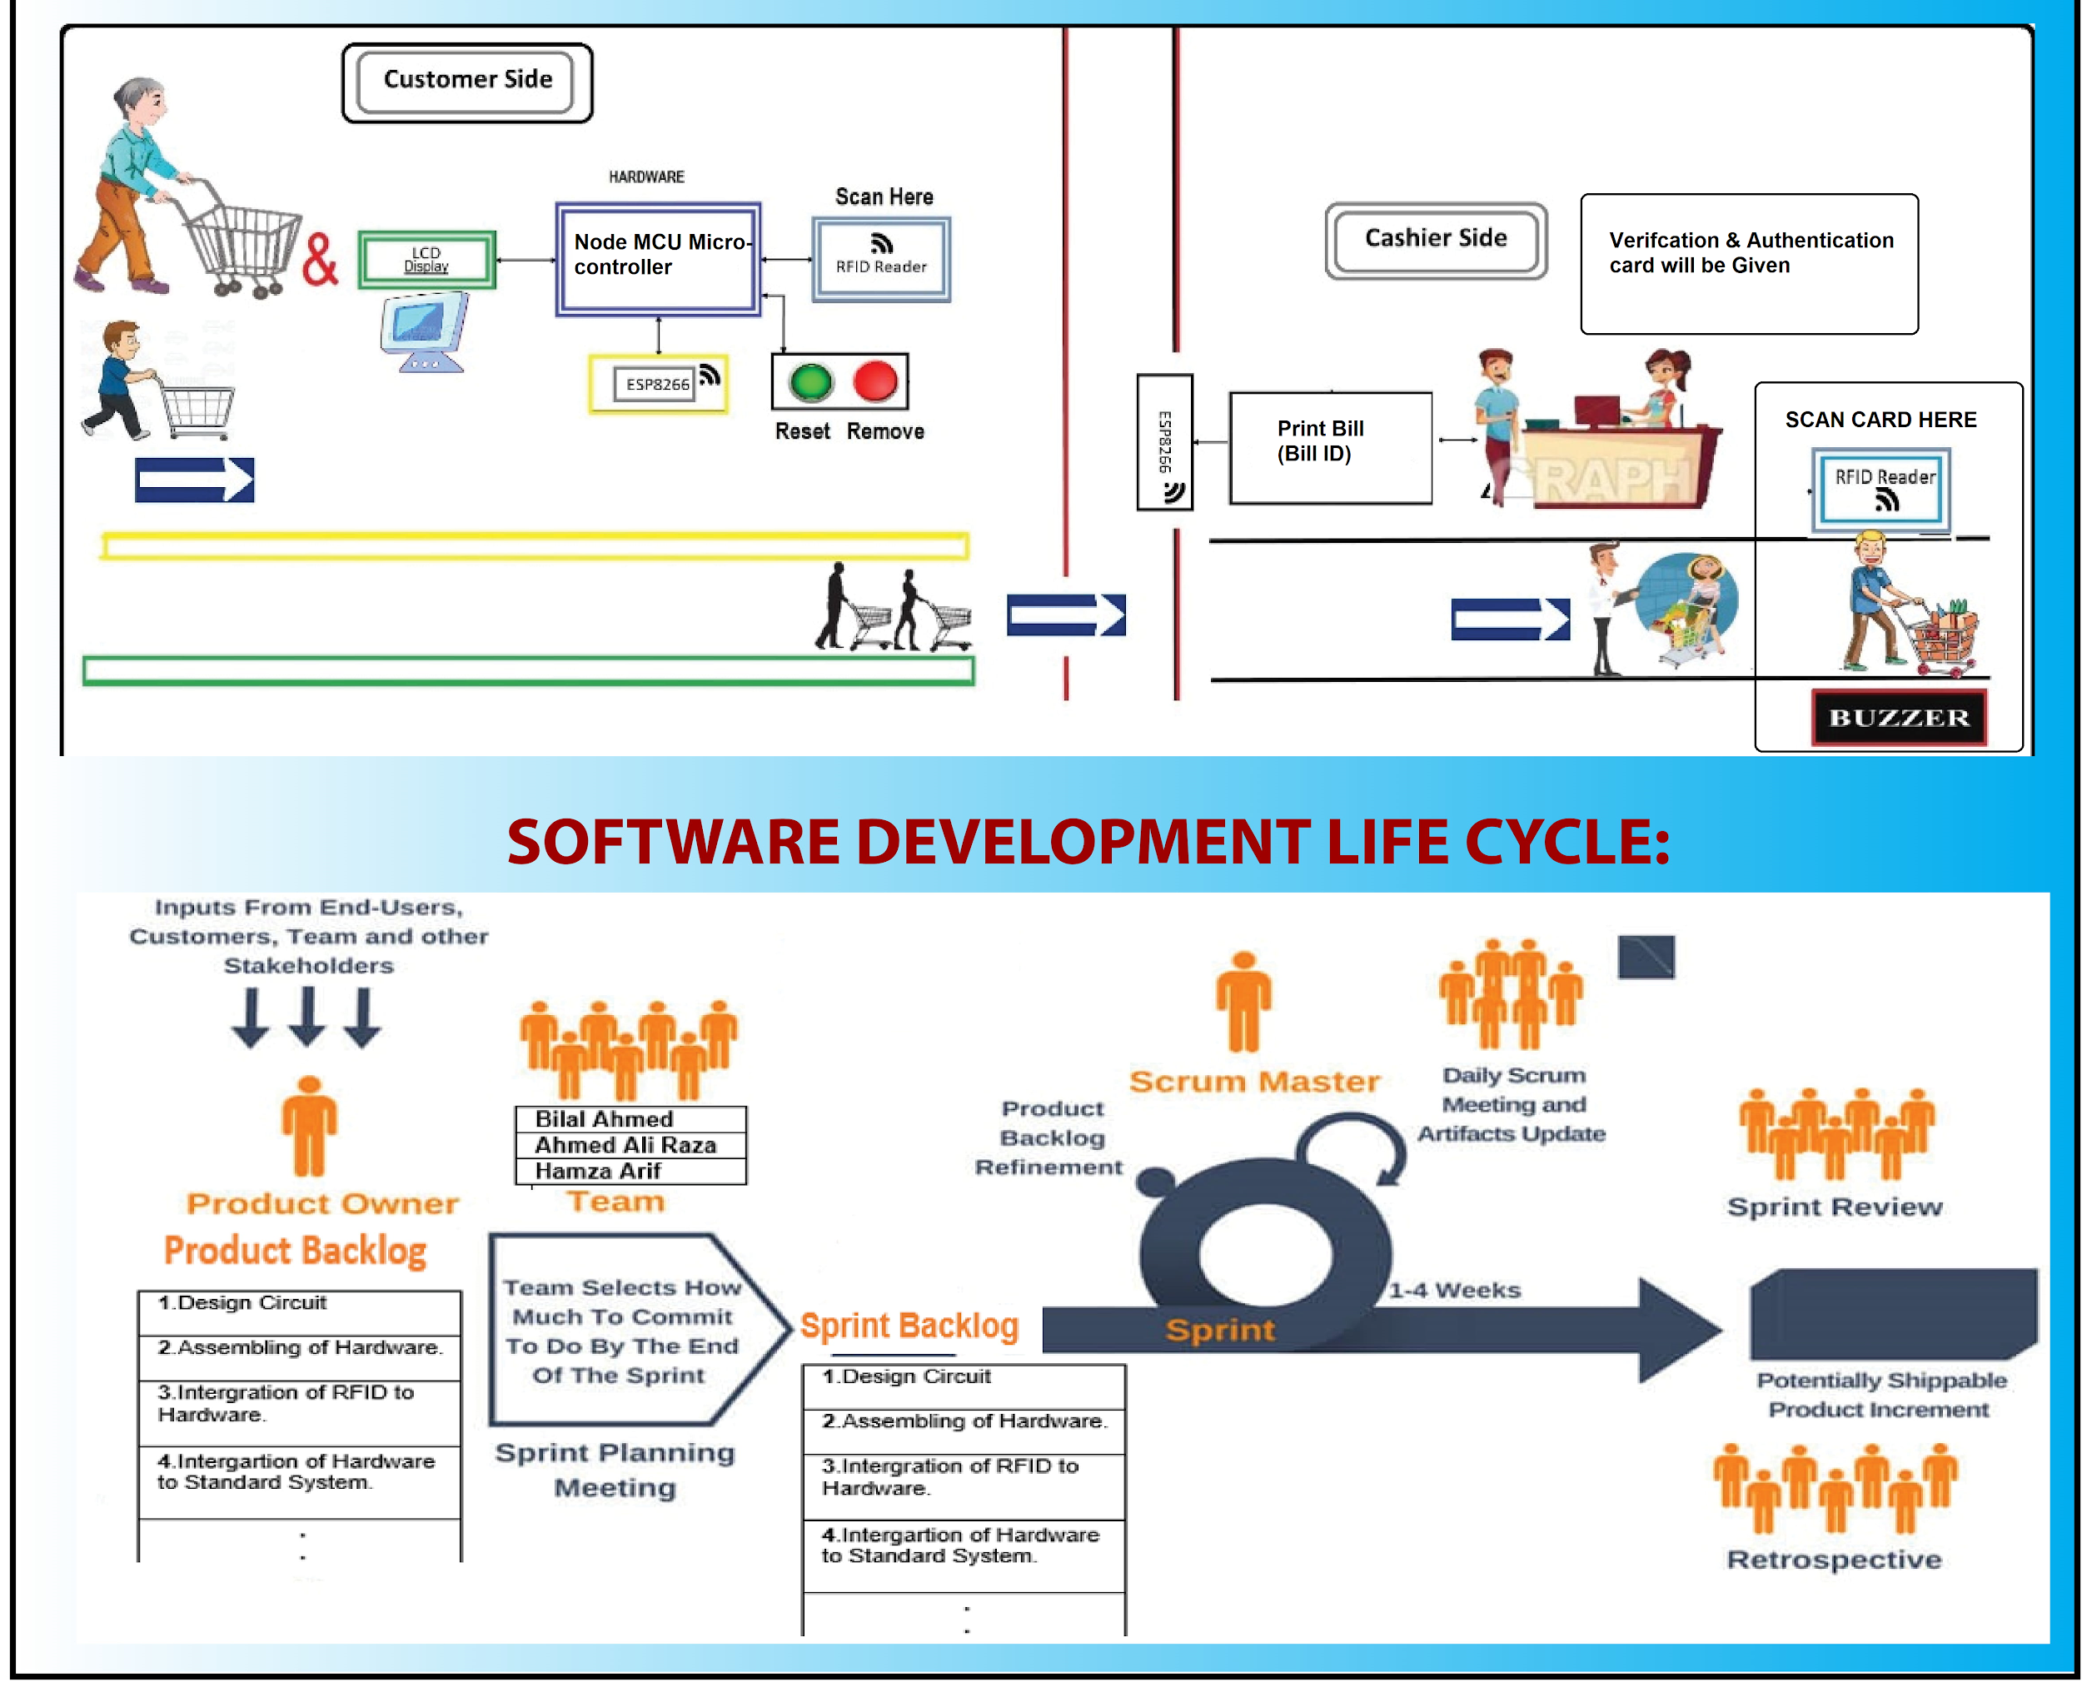

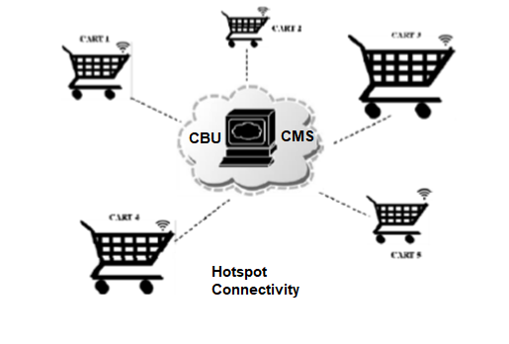

**FEATURES:**

* Anti-theft Alarm.
* Interactive LCD.
* Automated Billing System.
* Individuals items description through LCD and RFID.
* Add /Remove Product in the Cart.
* Remove Button to Remove Item from Cart.
* Reset Button to Reset Cart.
* Item name and cost will be displayed on LCD.
* The total bill amount displayed in the Cart.
* The RFID label Can be read and rewritten.
* Time Diminishing.
* The solution is people who come up with a fixed budget.
* Amount will be displayed in the Cart.
* Labor intensive reduced from automated processes
* **Functional Requirements;**

**System features;**

* Every product in the store will have an RFID tag on it.
* There will be a Centralized Server System and Database which holds the information of the products.
* The product RFID tags should be scanned and added to the bill.
* Cart will have an RFID reader with Arduino and ESP-8266 communication.
* When a customer wants to remove any product from the trolley, then that product needs to be scanned again, displays of items bill on the LCD and centralized database will be updated.
* Display Product price and total Bill amount.
* After the payment of money, the Cart will be reset with the button given in hardware.
* The customer Cart ID will be verified and the product will be counted before paying the bill.
* The customer will get the printed form of bill to pay and then items will be packed and customer can leave.
* **Non-Functional requirements:**

**System: Easy/Difficult for the Customers:**

This implementation is used to assist a person while shopping and also to avoid standing in long queues and saving time

* Ease of use for customer: since we are using RFID reader and other components it will be new to the customer so it would be difficult for the customer to understand and use for the first time but once they have used it, they will know how to use and will make it easier when they constantly used it.
* The other factor that can affect project is the average time that what time from a customer entering a mart till the customer get bill on the cash counter without any difficulty or error in between.
* The customer can enter many products and remove any at time, since its centralized billing going on the Billing unit the workload of cash counter has been altered and can save 1 person pay and use it for increasing efficiency of product.
* First time customer used the project, some person has ease to understand and some have difficulty but for the first time they will be shown how to use it and complete the task of what project is made for.
* As the multiple user will access the system at the same time, therefore the software needs to be efficient and reliable.
* The accuracy of the project is calculated by the accuracy of calculating the bill of the customer.
* Security requirements should be fulfilled by only the data administrator has the rights to access the database with and ID and password.
* The automatic cart we are making which can add/remove product and update at the same time in database and calculating the total bill of all the customers separately that uses our project in the mart. Performance is that quality that shows you how responsiveness is the system and database updated at equal time and bill is generated in CBU, user interactions

with product decides the performance of product. Poor performance leads to negative user experience. The system security can fail when it gets overloaded.

**System Availability:**

* Availability of the product is defined that all the hardware components are available that are being used in system the RFID reader, RFID tags, Arduino kit, ESP8266 etc.
* Availability of the services that the RFID reader reads the tags and added in the cart which also being edited in database and bill will generate at the CBU and given to the customer, ensures that will work properly.
* Availability of the database and hardware app and CBU work together at the same time.

**System Scalability:**

It’s being defined that the technology can grow with positive performance and since its increasing in the last few years, we can make hardware compatible and software that can take load and database does not fail. The automatic cart we are making which can add/remove product and update at the same time in database and calculating the total bill of all the customers separately that uses our project in the mart.

**--------------------------------------------------------------------  
Chapter 4;**

**Project Plan & Initial Design**

**----------------------------------------------------------**

* Work Distribution:

|  |  |  |  |
| --- | --- | --- | --- |
| **Work Distribution** | **Member 1** | **Member2** | **Member3** |
| Design Circuit of hardware (ASC) |  |  |  |
| Designing of Cart with Hardware |  |  |  |
| Assembling of Hardware |  |  |  |
| Developing (Coding) of Arduino |  |  |  |
| Integrating the RFID tag to Product ID |  |  |  |
| Hardware Testing |  |  |  |
| Design Database |  |  |  |
| Database with table Entities and attributes |  |  |  |
| Integrating Database with RFID Tags |  |  |  |
| Connecting Database with Web Application  with RFID Tags and Cart ID |  |  |  |
| Integrating Billing System with Cart(Hardware) |  |  |  |
| Testing of all modules (software & hardware) |  |  |  |
| System Testing and Maintenance |  |  |  |
| Implementation |  |  |  |

* **Weekly Chart:**

|  |  |  |  |
| --- | --- | --- | --- |
| ***S.***  ***No.*** | ***Elapsed time since the start of*** the ***project*** | ***Milestone*** | ***Deliverable*** |
| *1.* | *Week 01* | Research of Suitable ideas | Potential Ideas |
| *2.* | *Week 02* | Brainstorming of Ideas | One specific idea for Project |
| *3.* | *Week 03* | Requirement gathering (Market survey for main Equipment) | Budget and Specifications of hardware |
| *4.* | *Week 04* | Requirement gathering | Software process model |
| *5.* | *Week 05* | Preparation of Use case Diagram | Use case Diagram |
| *6.* | *Week 06 - 7* | Verification of Proposal | Proposal Verified |
| *7.* | *Week 08* | Proposal Feedback | feedback Solution |
| *8.* | *Week 09* | Data requirement work distribution | ERD diagram work distribution |
| *9.* | *Week 10 - 13* | Poster presentation | Presenting the idea |
| *10.* | *Week 14* | Approval of proposal | Proposal accepted |
| *11..* | *Week 15* | Design Circuit of hardware (ASC) | Making Circuit Diagram |
| *12.* | *Week 16 - 17* | Assembling of Hardware | Purchasing of hardware component |
| *13.* | *Week 18* | Developing (Coding) of Arduino | Coding in Arduino to identify product |
| *14.* | *Week 19* | Integrating the RFID tag to Product ID | Assigning RFID tag to Product ID |
| *15.* | *Week 20 -22* | Hardware Testing | Testing Hardware |
| *16.* | *Week 23* | Design Database | Database Design with tables |
| *17.* | *Week 24* | DataBase with table Entities and attributes | DataBase Created in MySQL |
| *18.* | *Week 25-26* | Integrating Database with RFID Tags | DataBase Integrated with RFID Tags |
| *19.* | *Week 27 – 30* | Developing the Web Application | Web Application |
| *20.* | *Week 27-30* | Creating Web page | Web page |
| *21.* | *Week 28-29* | Creating UI for Web Application | UI Interface |
| *22.* | *Week 27-32* | Developing Code for Web Application in HTML,PHP | Working of Web Application |
| *23.* | *Week 32-33* | Tested Desktop Application | Testing and debugging Desktop Application |
| *24.* | *Week 34-35* | Connecting DataBase with Desktop Application  with RFID Tags and Cart ID | Integrating Desktop Application with Database with RFID Tags. |
| *25.* | *Week 36– 38* | Integrating Desktop Application with Hardware | Integration the both module |
| *26.* | *Week 39 – 40* | Testing of all modules (software & hardware) | Testing all module |
| *27.* | *Week 41-44* | System Testing and Maintenance | Testing and Performance testing |
| *28.* | *Week 45-49* | Implementation | Optimized Product |

* **GANTT CHART:**

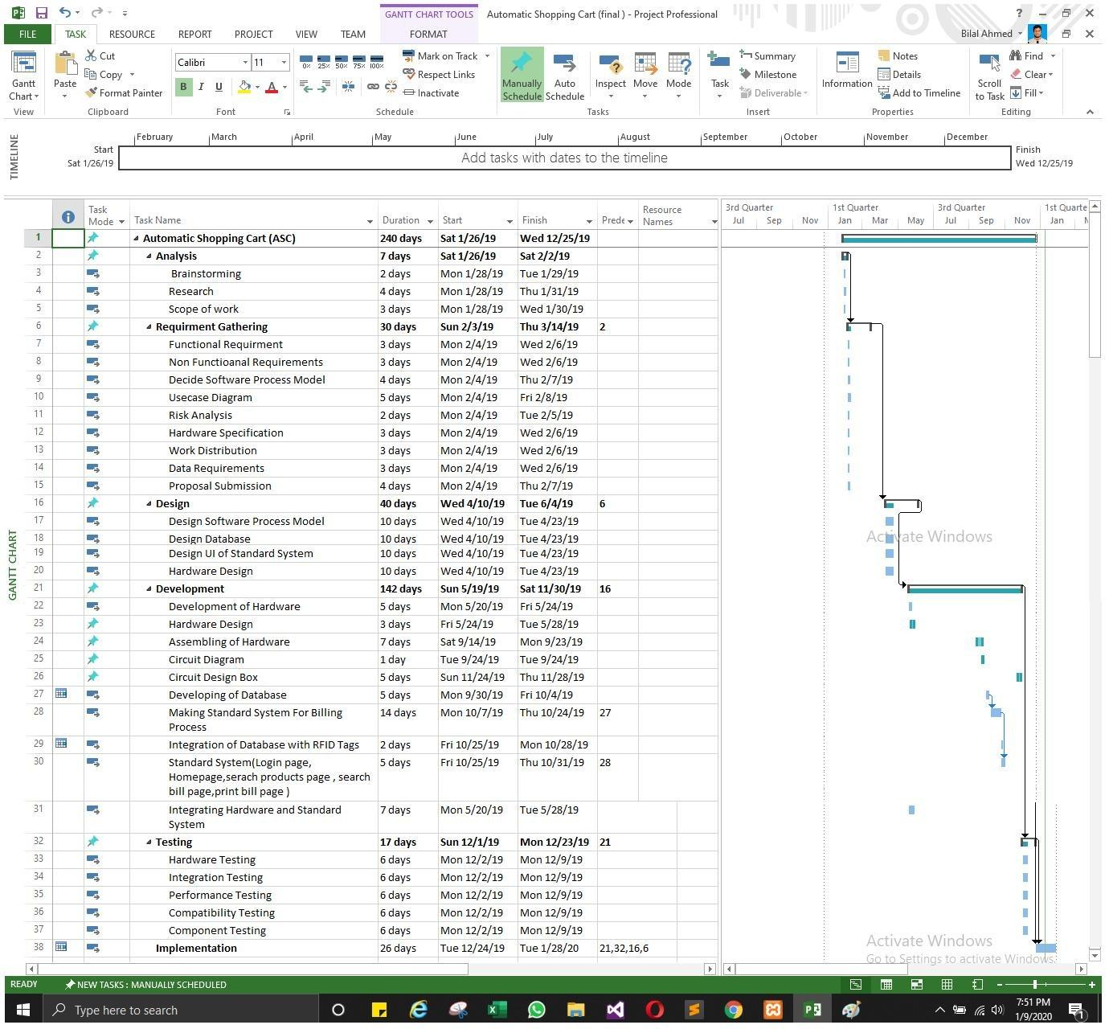

* Add all diagrams including use case, sequence, activity, and DFD (whatever are applicable). You can add it to your FYP1 report.
* **USE CASE DIAGRAM:**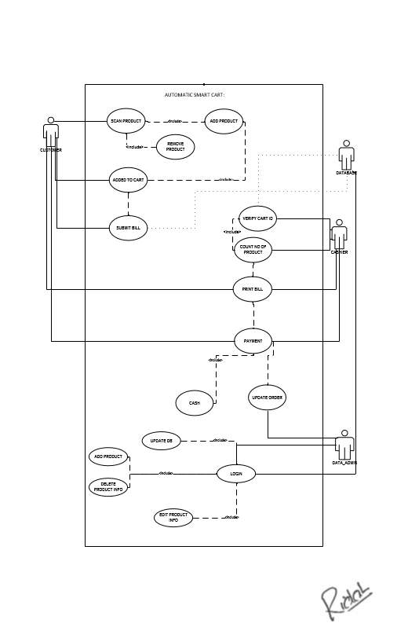
* **ACTIVITY DIAGRAM:**

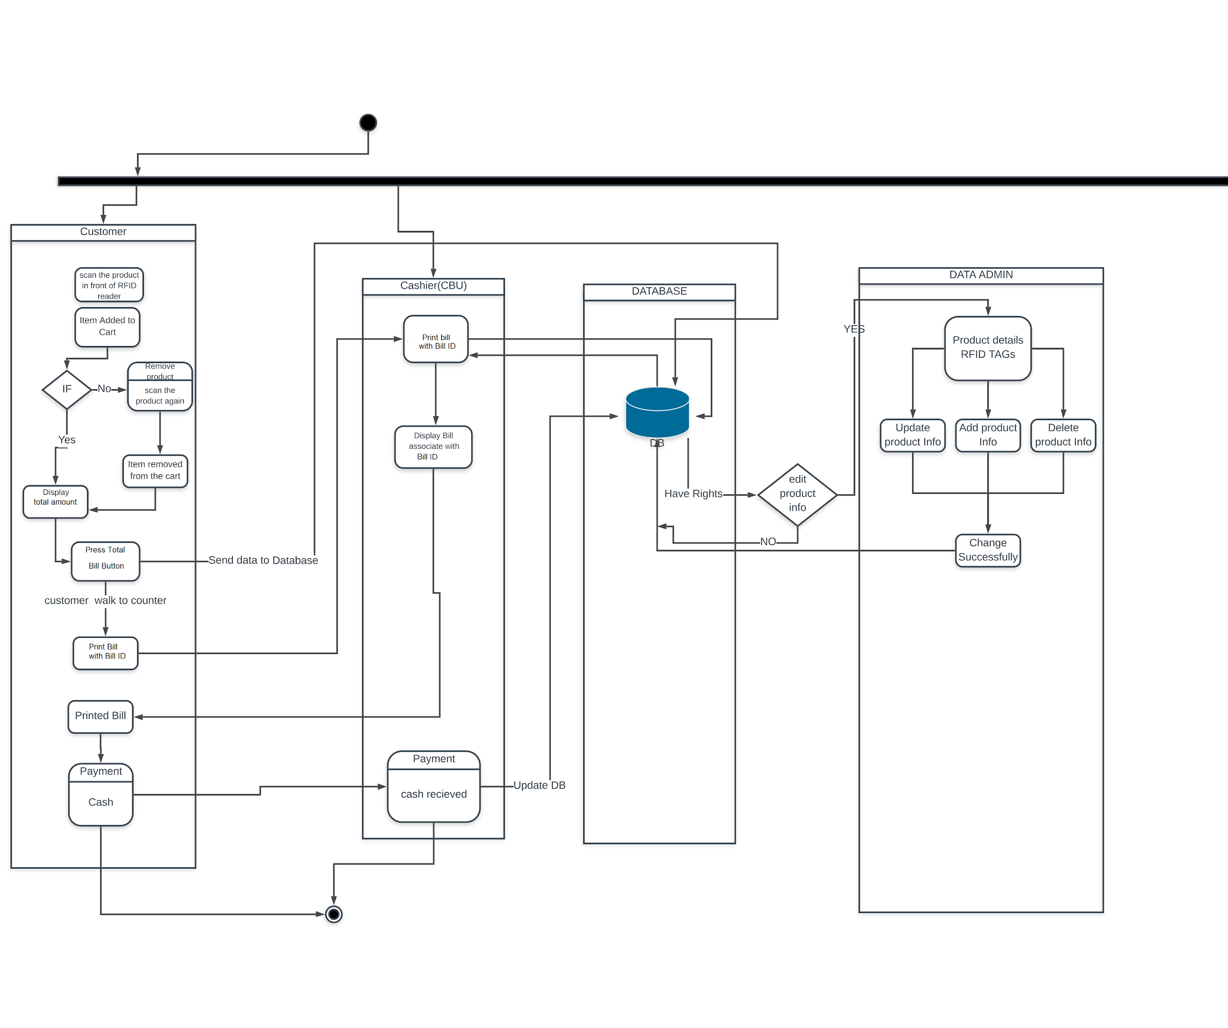

* **Class Diagram:**

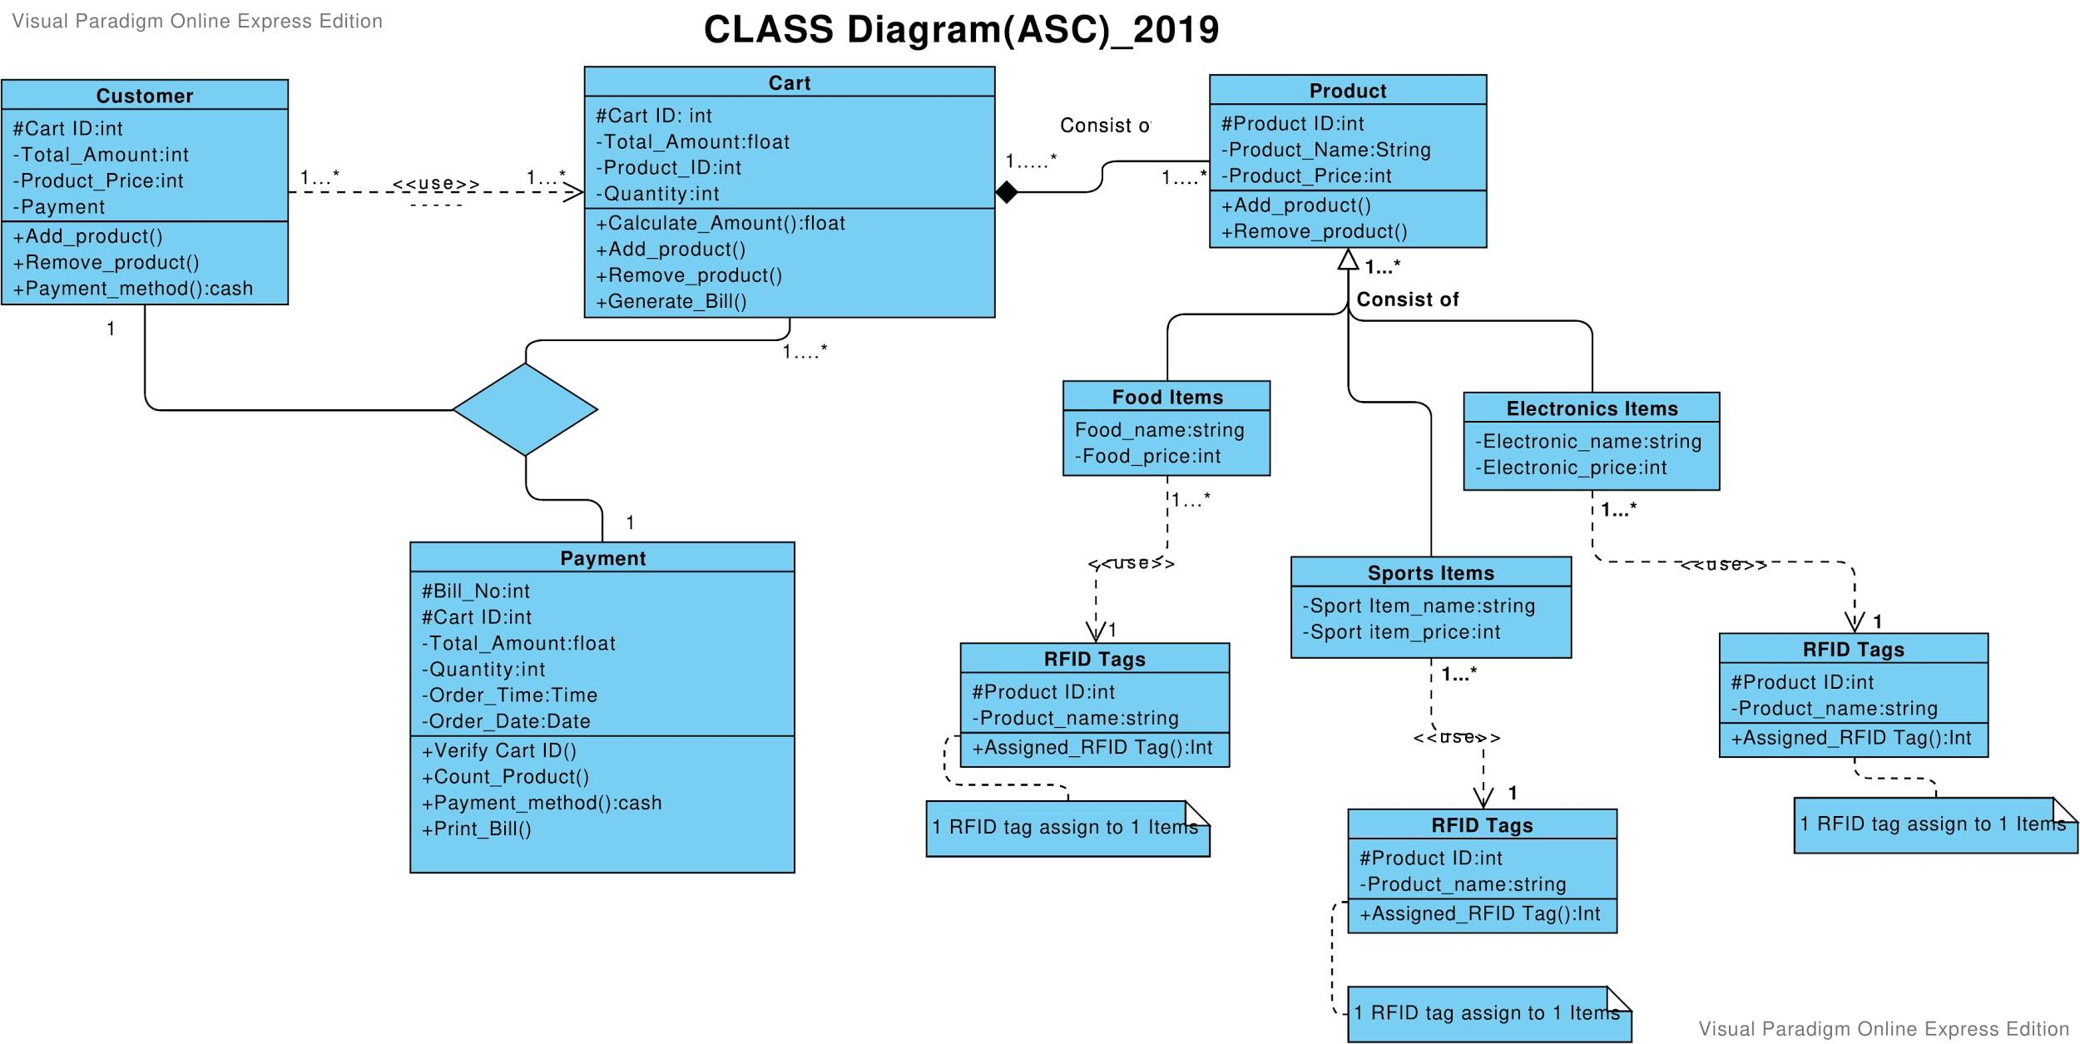

**ERD Diagram:**

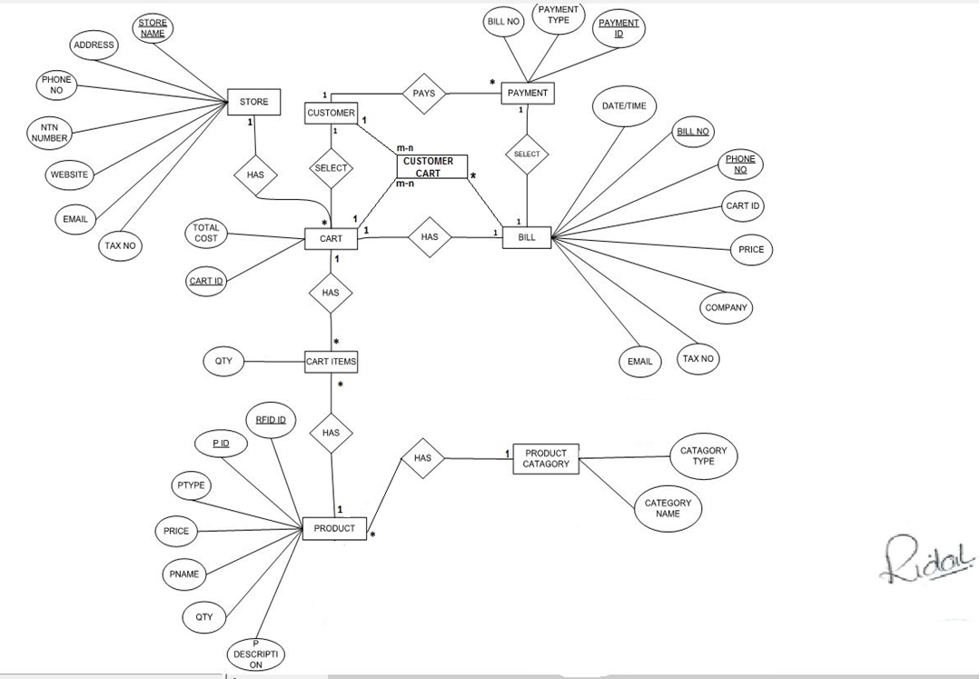

**CIRCUIT DIAGRAM:**

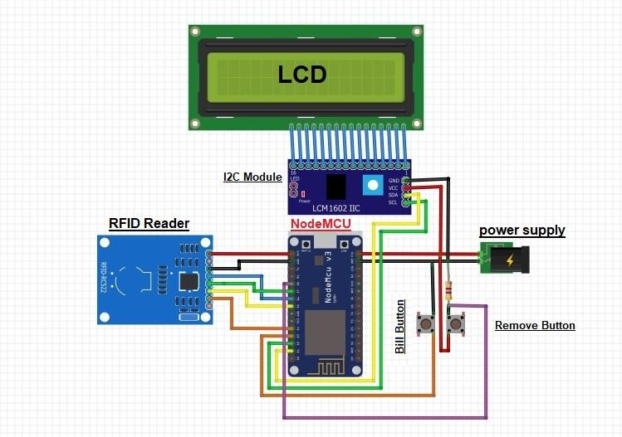

* Add Prototype (blueprint) or initial design of your UI, which was made before starting the project



* **Model Description:**

The software model that we are using is the agile software development model in our project because since our project is hardware and software integrated project(Automatic smart Cart), since agile method uses incremental/iterative approach for designing a software, so we can break the product modelling into small modules or different increments which is easy to follow rather than making the whole project phase by phase and testing it after building the whole system, and in agile model every iteration has ended and sprint is tested and we can get feedback at that time. we can manage small modules to make a whole system which includes hardware, since we are clear about the requirements and what is the scope of our project.

* **SCOPE:**

A Shopping Cart that should be possible conceivable by essentially interfacing RFID marks to the things and Display with an LCD in the obtaining Cart. From this customer can add/remove product and can also get information identified with expense of everything which are inside Cart and moreover supreme expense of the thing about the item. This system will spare time and work required for of customers & labor. the system has anti theft alarm at the exit with RFID Reader with Buzzer.

**----------------------------------------------------------------------------**  
**Chapter 5;**

**Project Design & Development**

**-----------------------------------------------------------------**

* **Design**
  + Front End Design:  This includes color theme, logo, template, screenshots of the user interface of all screens and web pages, etc. with description.
* **COLOR THEME:**

(BLUE, WHITE, LAVENDER, BLACK)

* **LOGO: The LOGO of the Cartigo Management System(CMS)**

**SCREENSHOTS OF USER INTERFACES:**

* **LOGIN PAGE:**

The Login page where you enter the username and password and the username and password in saved in the Database. When you enter the Username and password it will fetch it from database and check the validation if its correct it will redirect to Homepage (profile.php) otherwise you would be redirected to the login page.

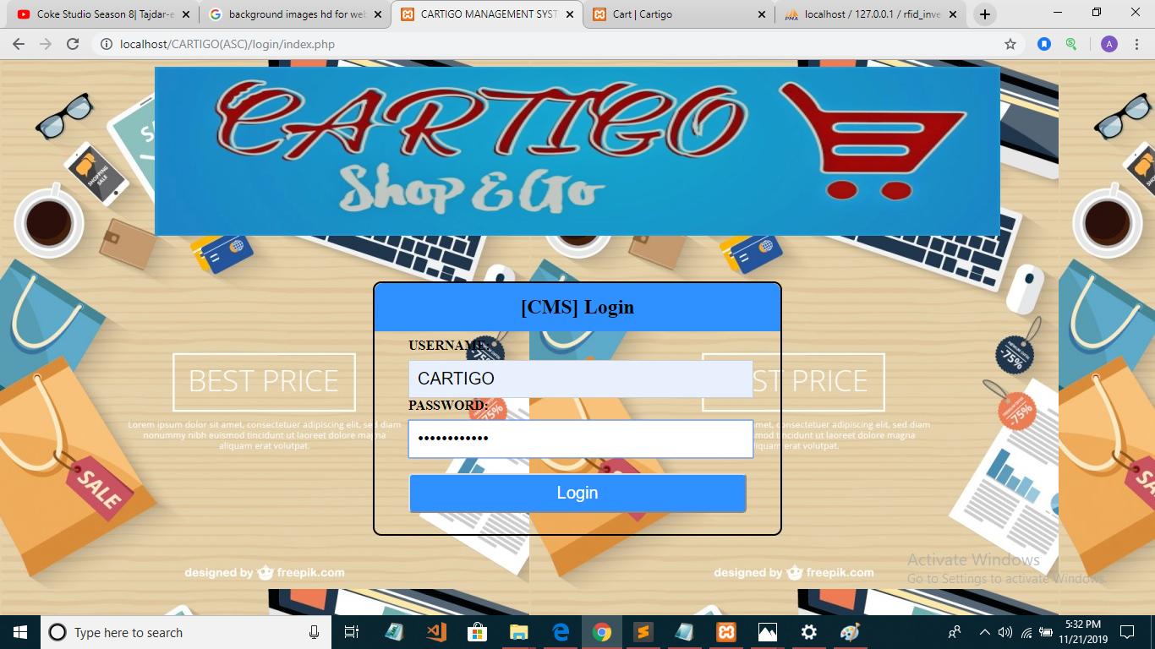

* **HOMEPAGE:**

The Homepage will be displayed when you Login to the web form and provided with all the navigation through different web pages, navigation Bar.

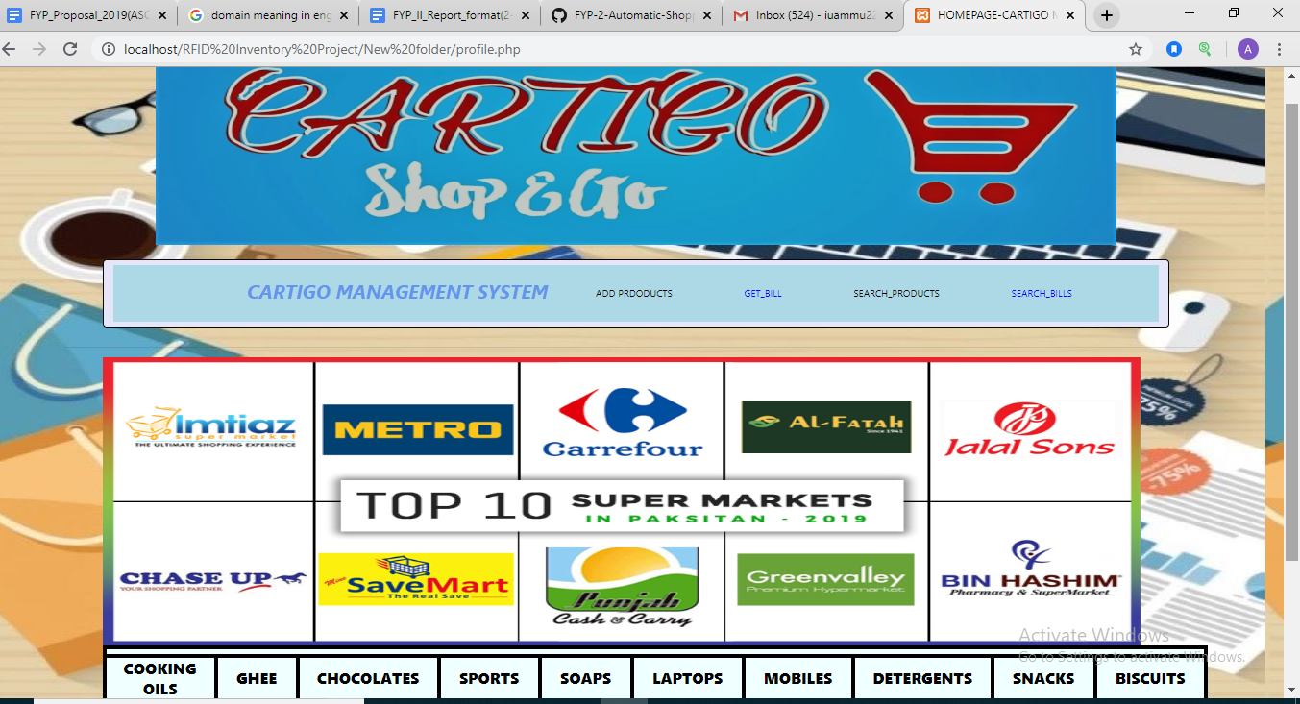

* **ADD PRODUCTS:**

The products can be added through web form when you click add new products button and you enter RFID, product name and products price and click on add products the products created message will be displayed in the web form and products also created in the Database.

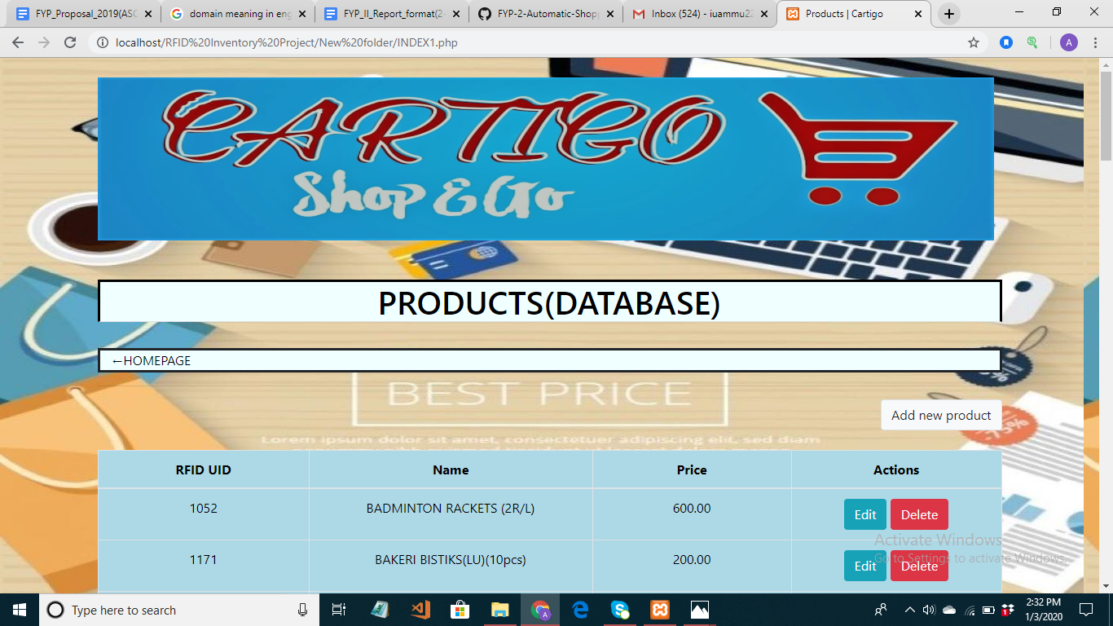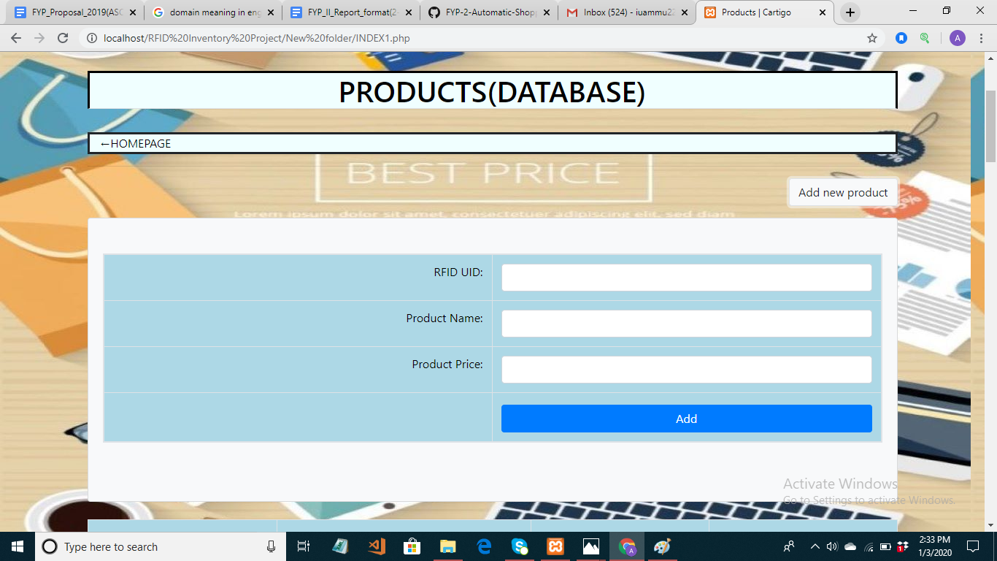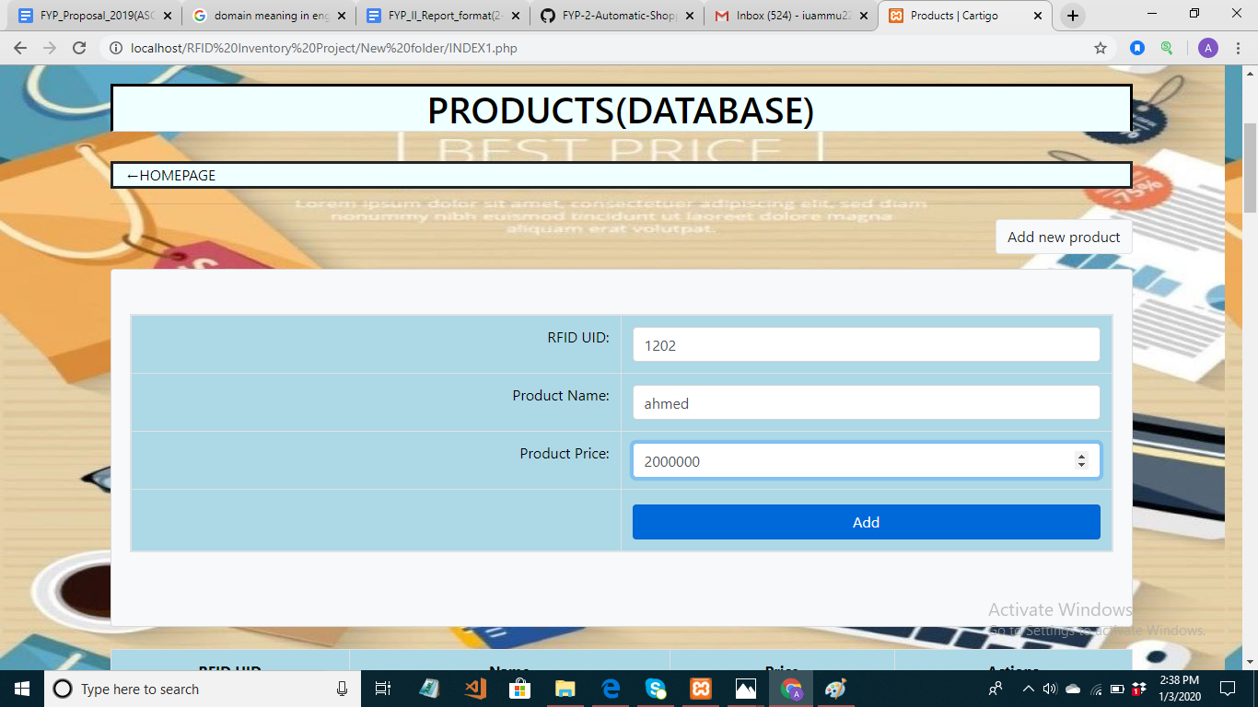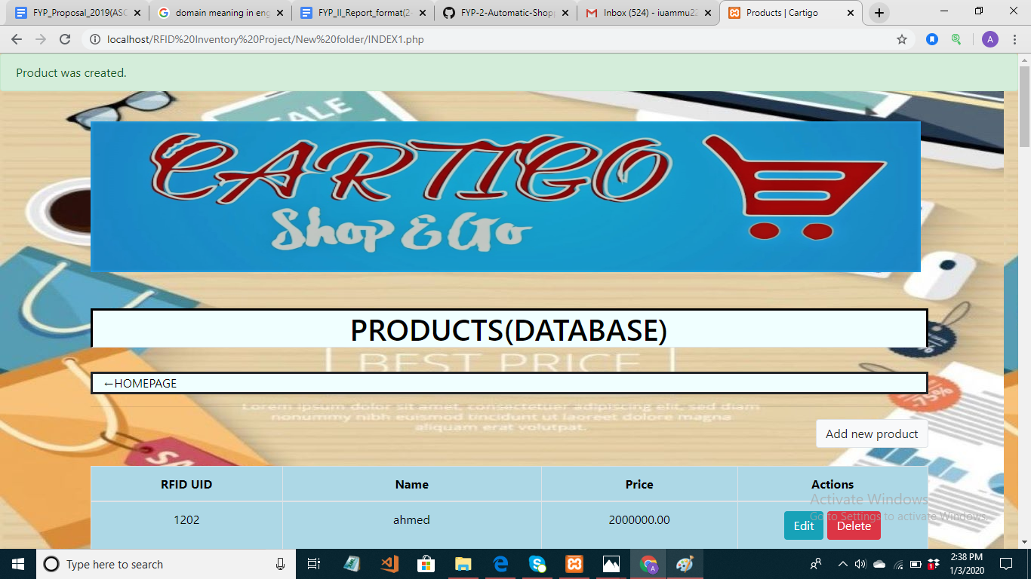

* **DELETE PRODUCTS:**

The products can be deleted by just clicking the delete button which will delete product all information through ID and the products will no longer be available in the Database. 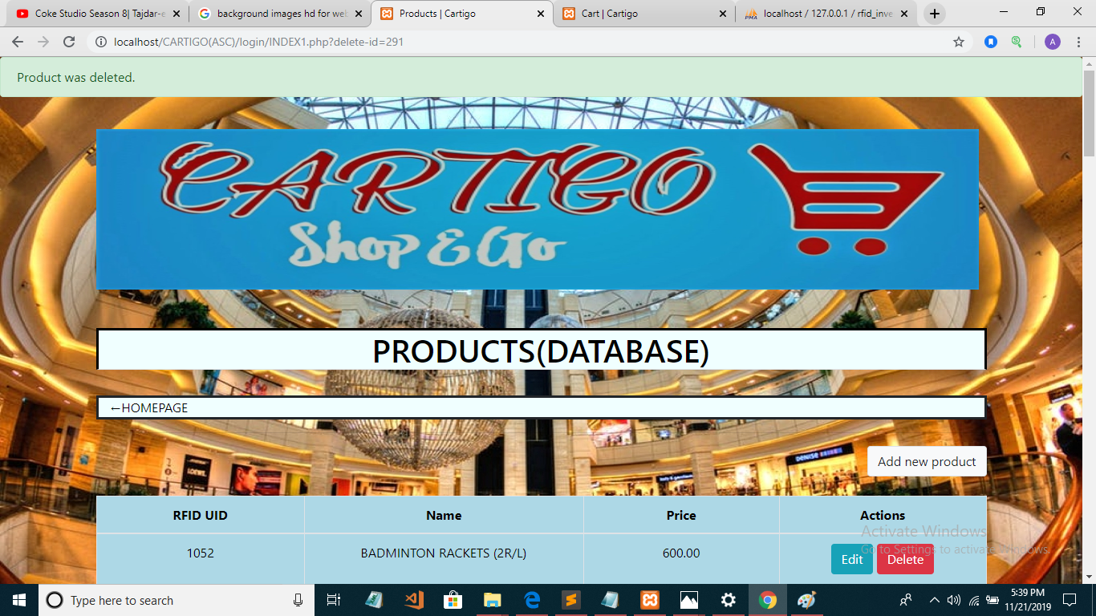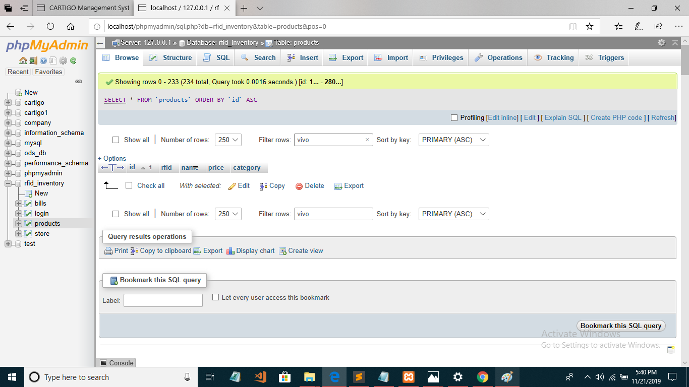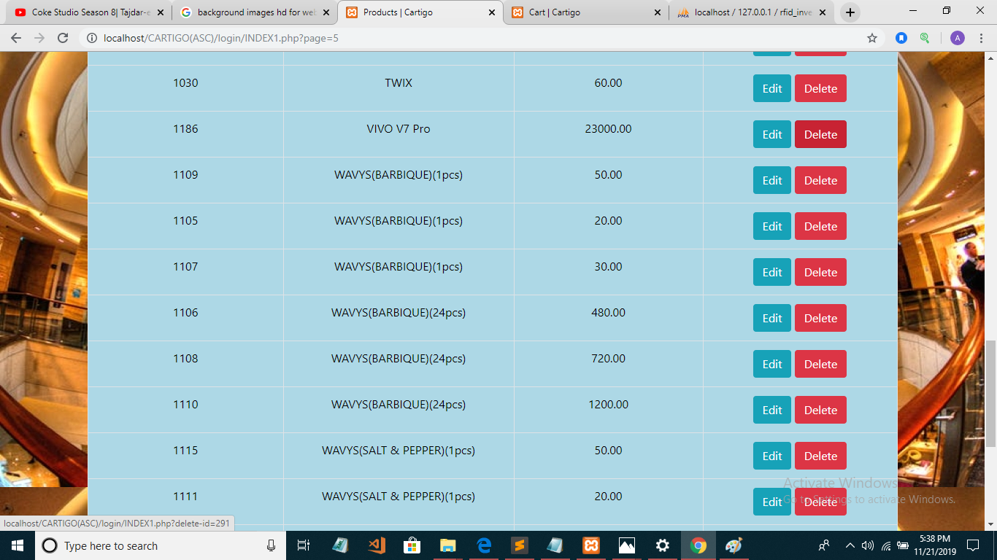

* **UPDATE PRODUCTS:**

The product information can be updated through web form which is connected with database updates also changes in the database when edited in the web form. 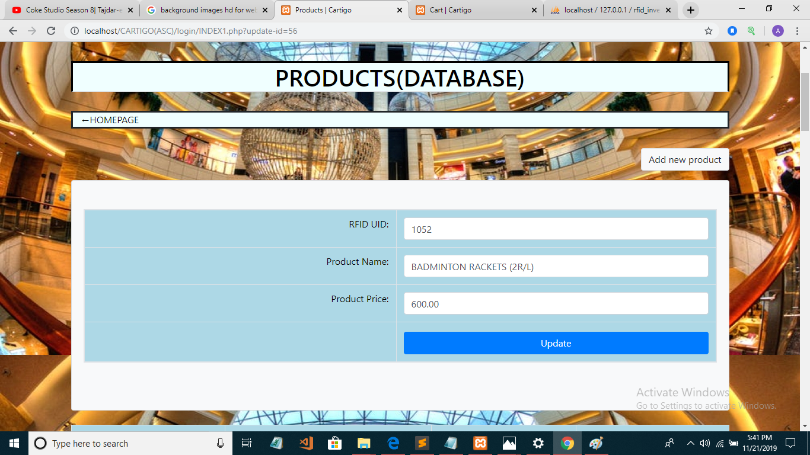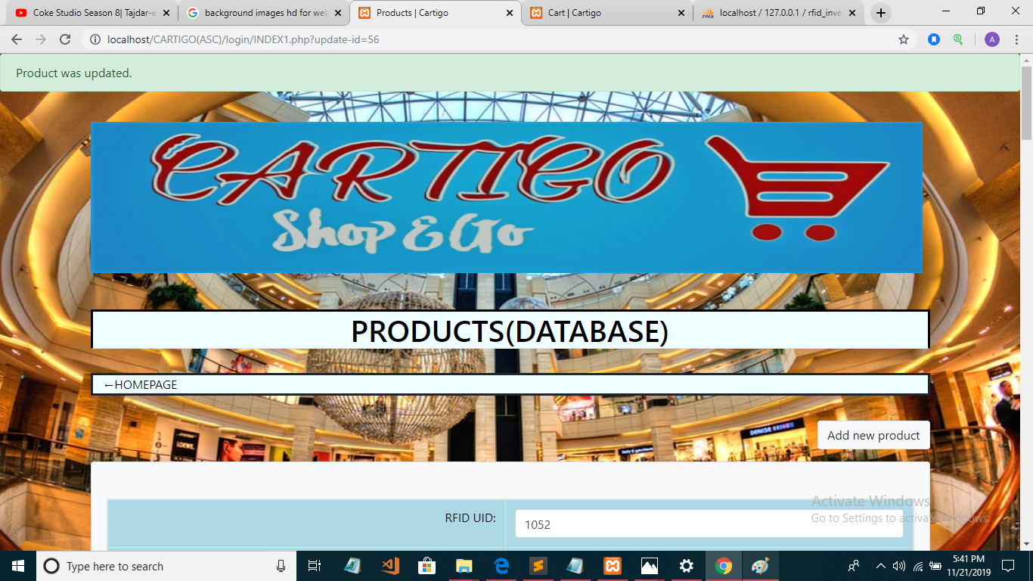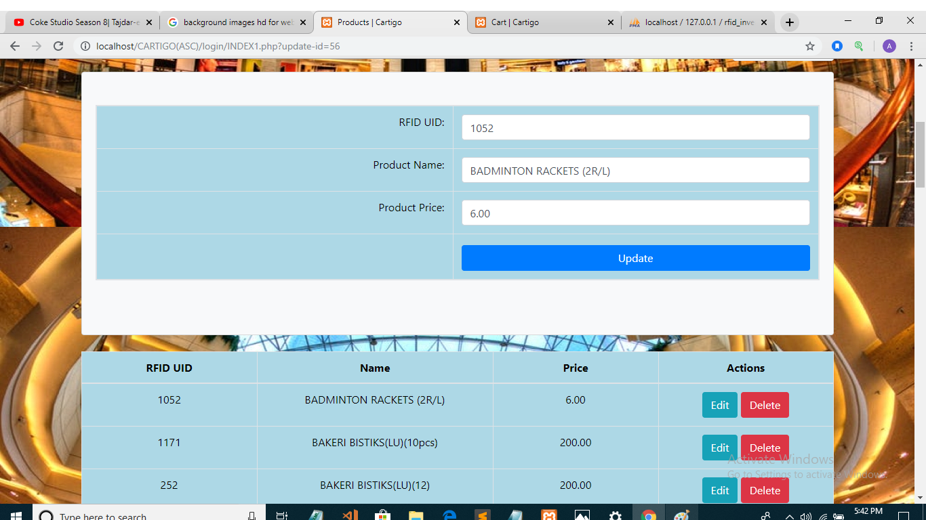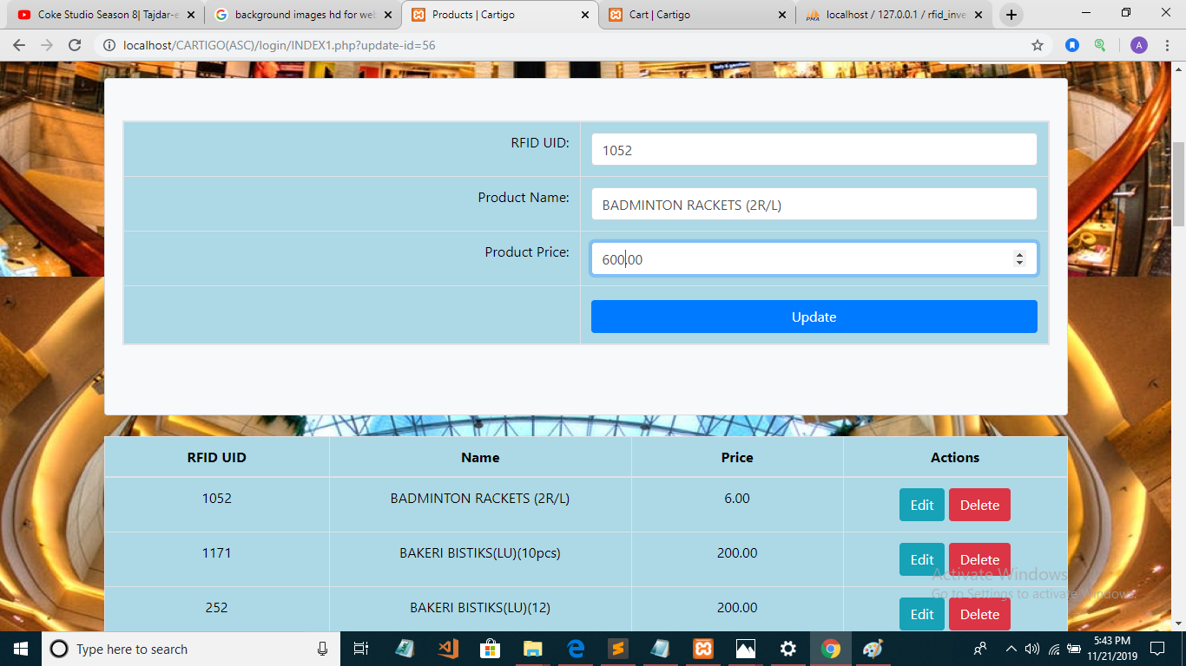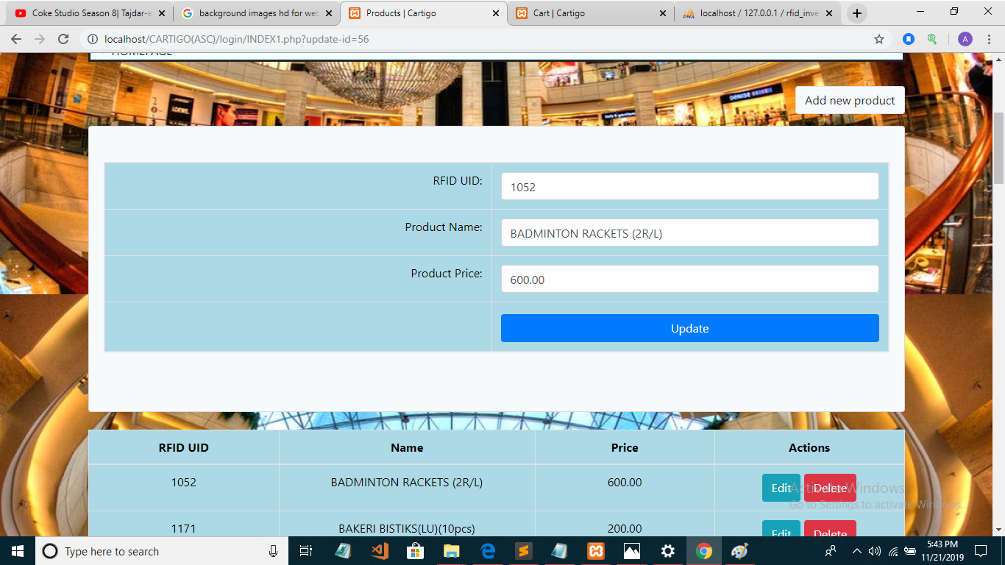

* **SEARCH PRODUCTS:**

The products could be searched by product ID which is different and you could find out the ID by navigating through the table in web page which has all information about products and their ID and RFID.

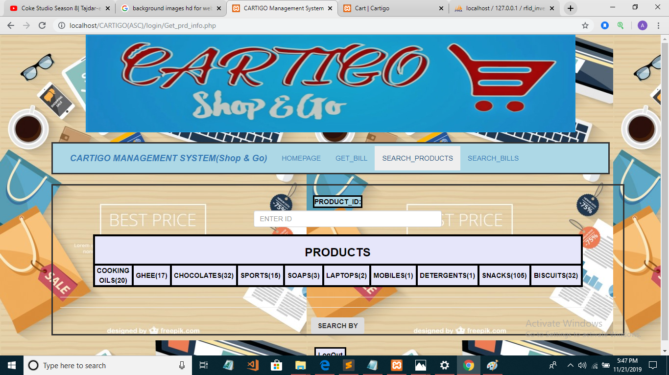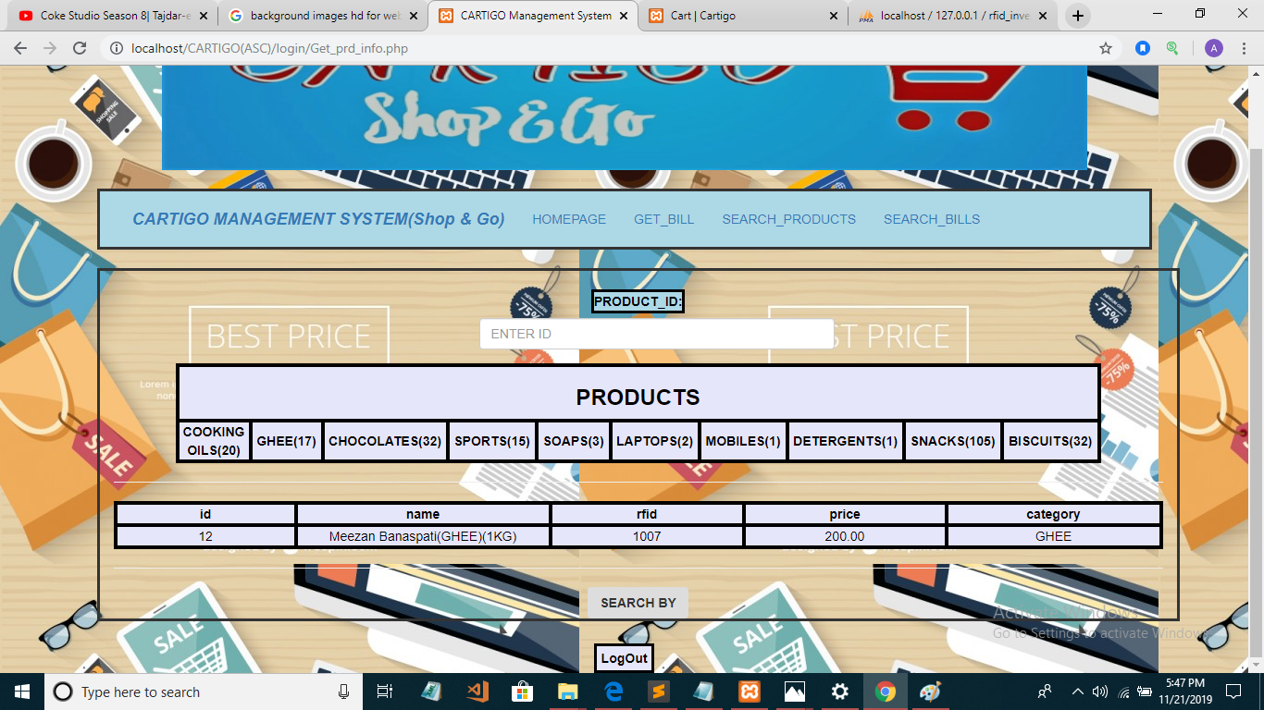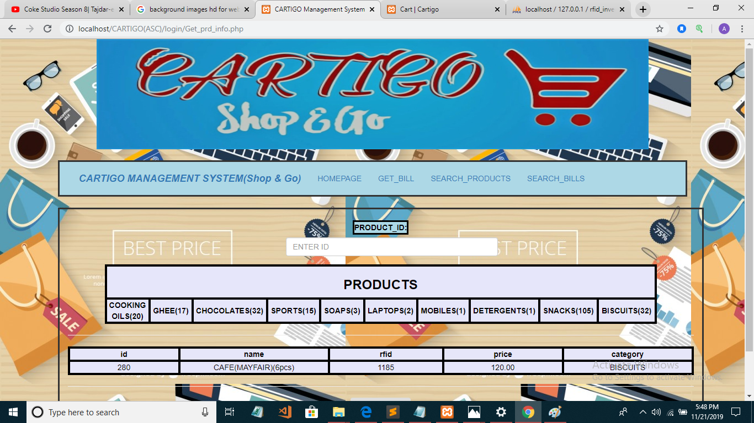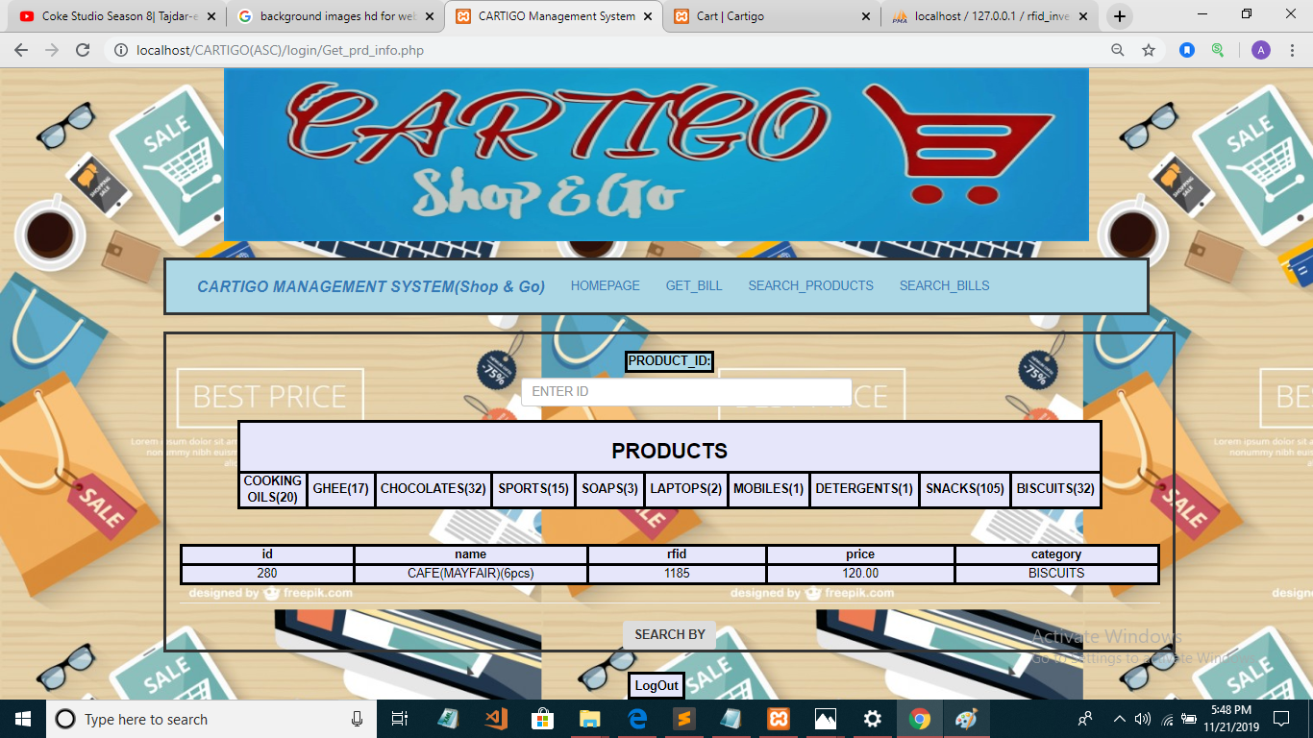

* **Navigation to products name and ID with Price:**

From the search products page you can navigate to pdf file of all products with their name, ID and price.

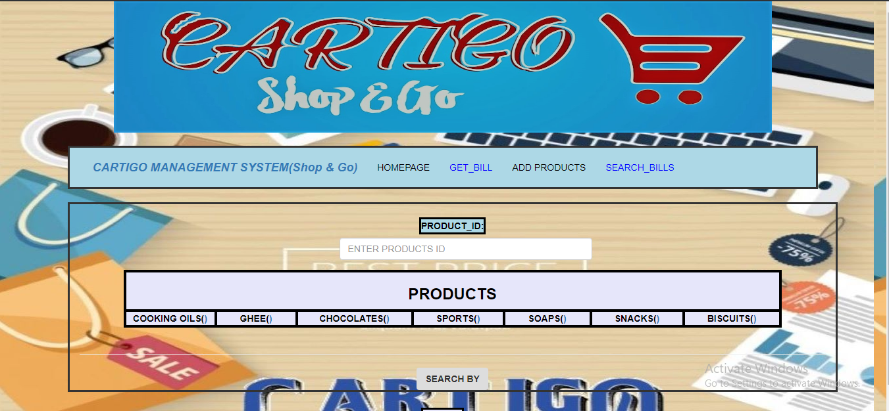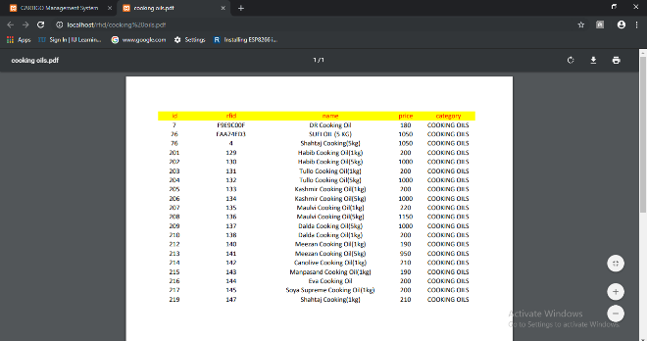 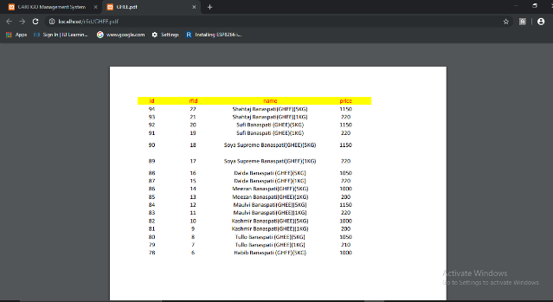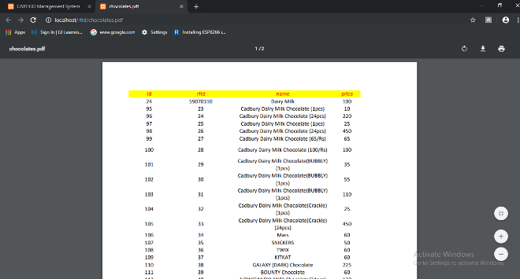 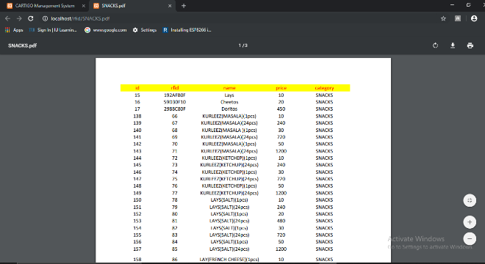

* **SEARCH BILL:**

Search the bill through bill ID and you will get the amount and through which you can find out bill saved in the pdf file. you can also give Cart ID to hardware and for multiple cashiers you need multiples hardware which could solve this issue. 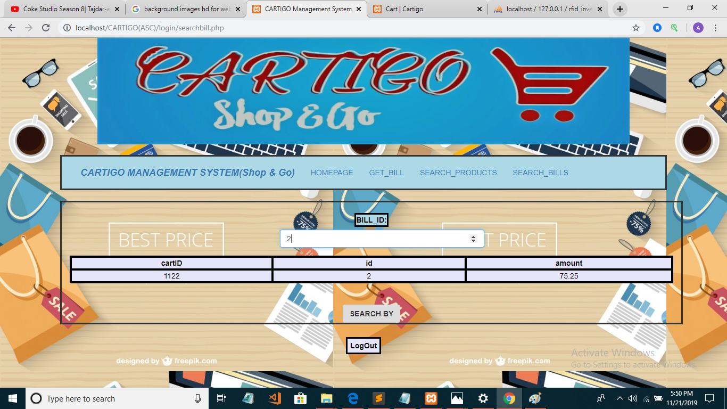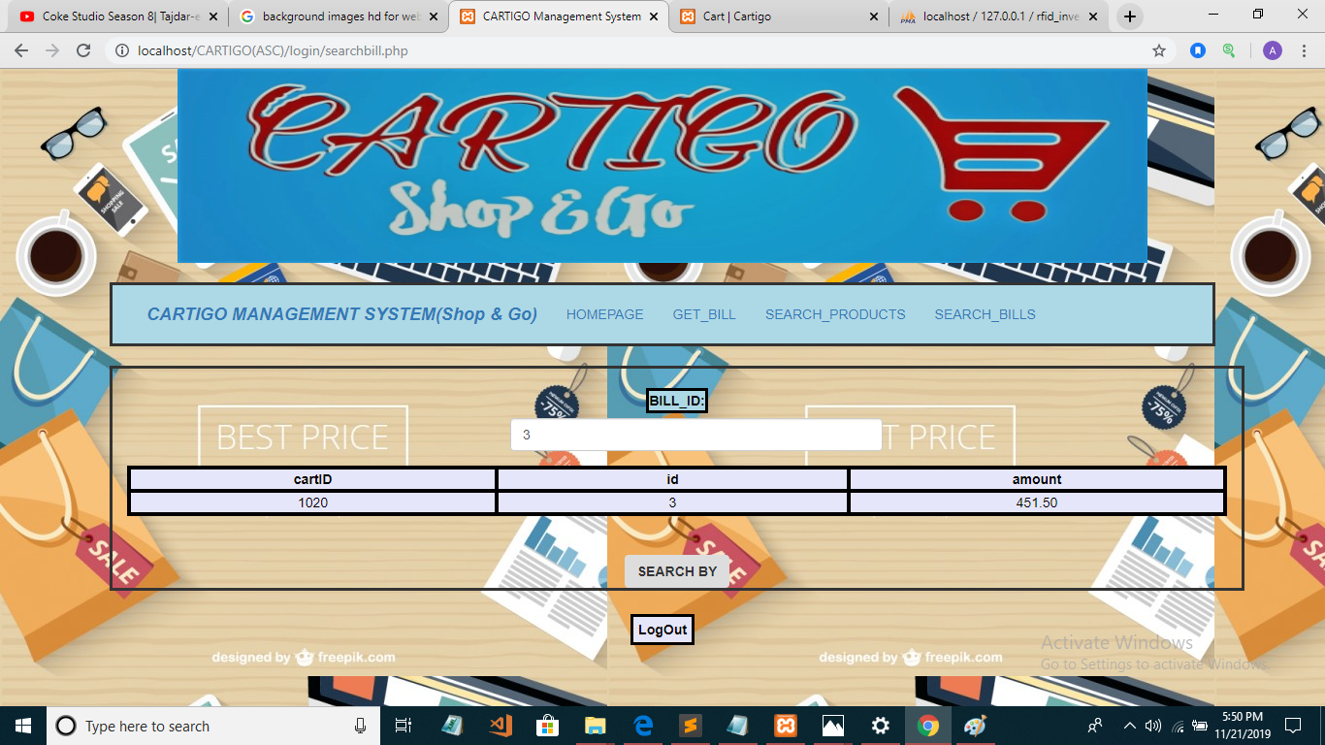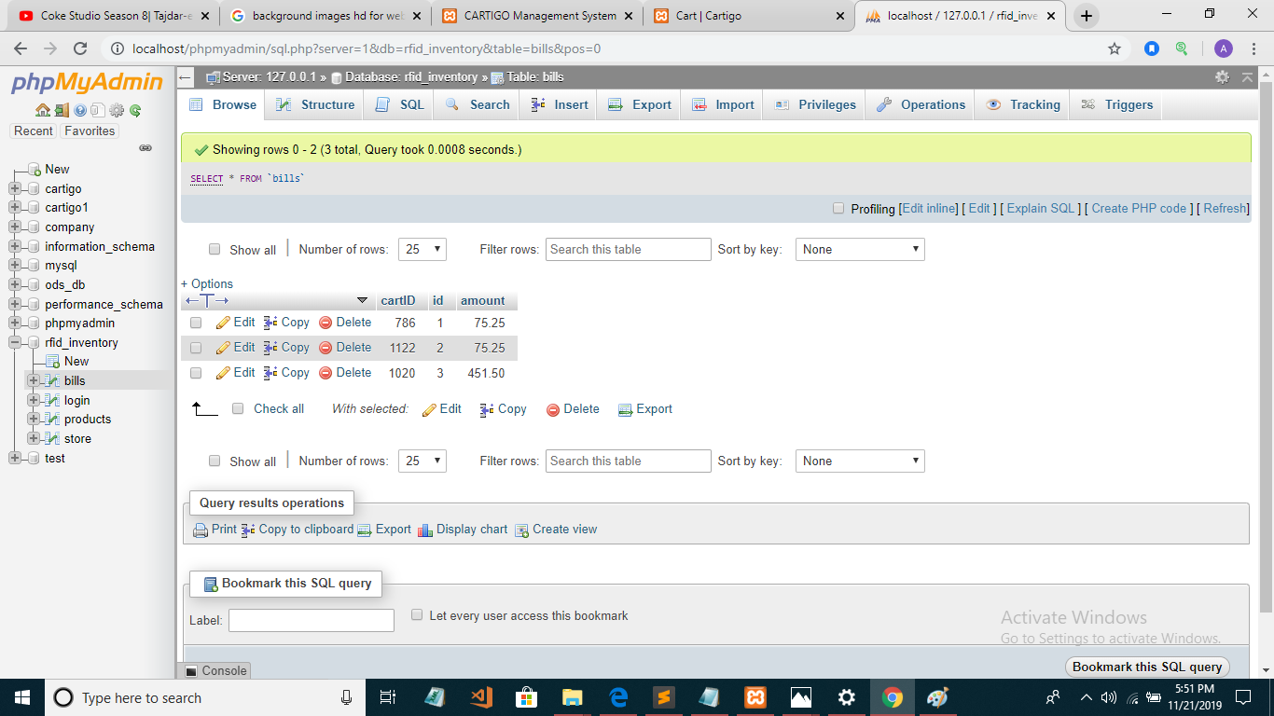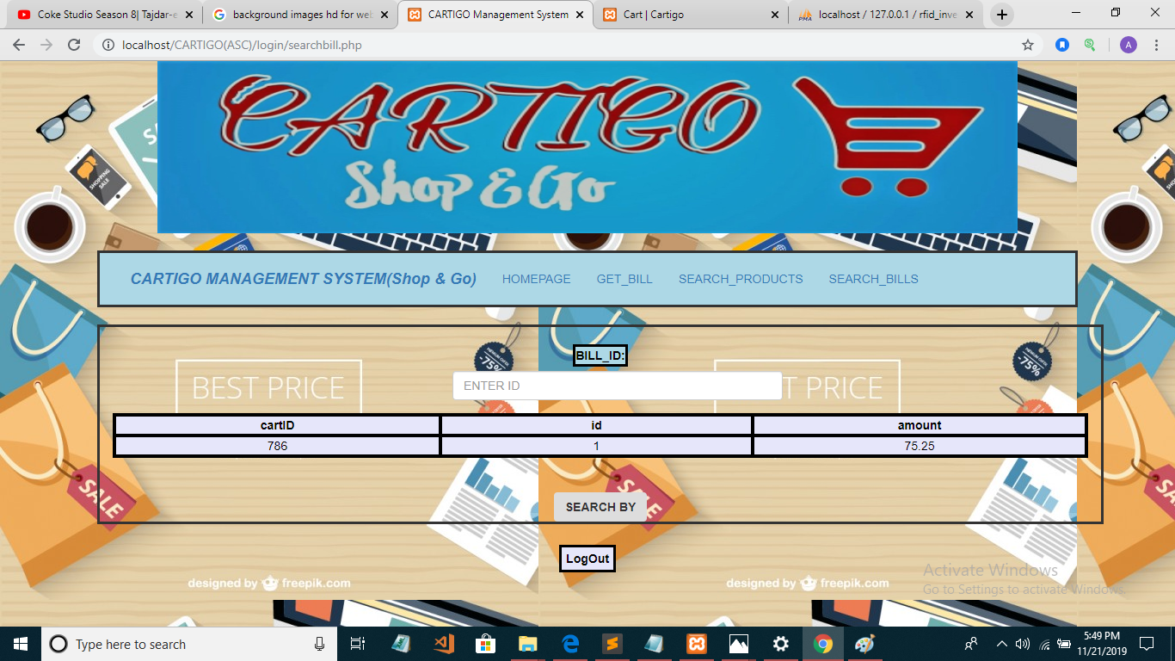

* **PRINT BILL:** The bill printed in bill format with all the products, price, quantity and total amount with unique bill ID when you press the total bill button on the hardware side the bill generated in the web form application.

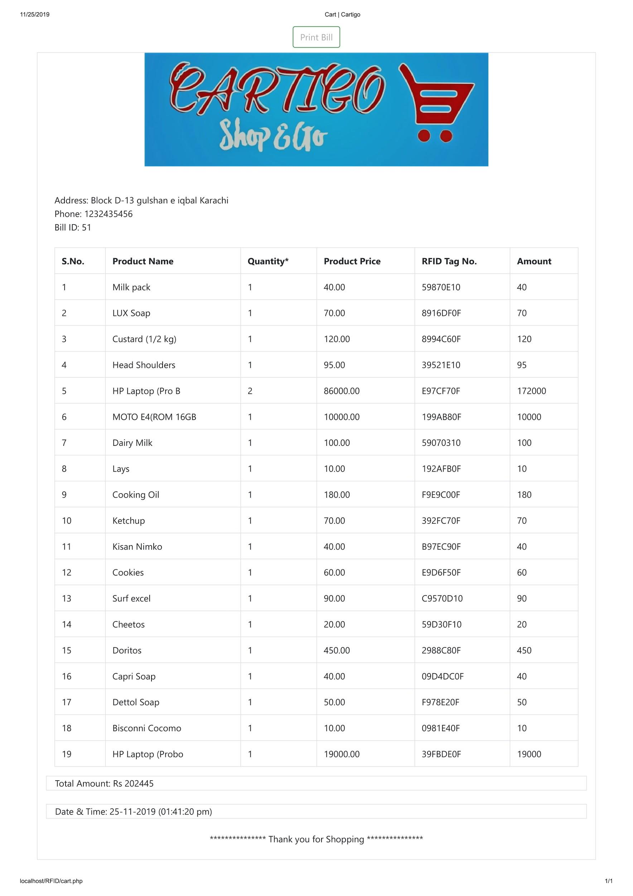

* + Backend Design: this includes physical ERD of the database designed directly using DBMS after implementing the conceptual design. It must have column types and sizes.

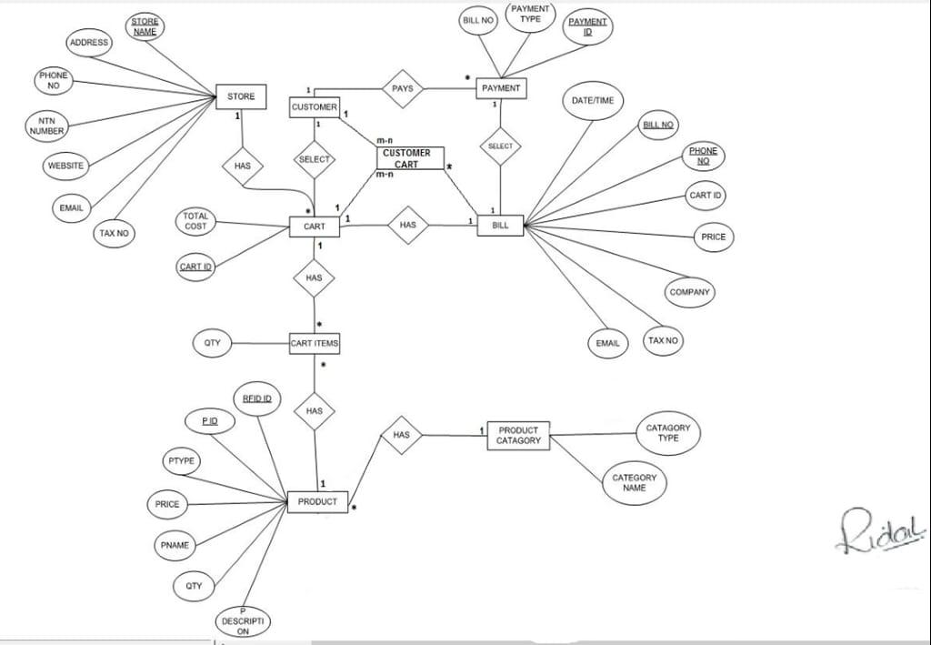

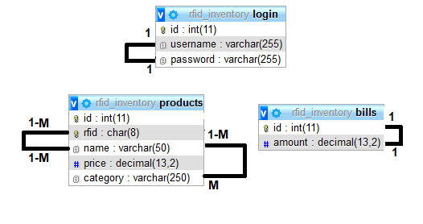

* **Development**
  + Discuss different stages of development, add code or any important logic you want to discuss. Your algorithm, running your algorithm and generating results screenshots, screenshots of your project structure, classes, and resources, important files screenshot, discuss code you used to design layouts and implement logic.
  + Mention libraries you used also the version of language and platform used to develop the project.
* **Languages:**
* C-Language
* PHP,
* Javascript,
* CSS,
* Bootstrap
* **LIBRARIES:**

1. <ESP8266WiFi.h>
2. <ESP8266HTTPClient.h>
3. <ArduinoJson.h>
4. <SPI.h>
5. <MFRC522.h>
6. <LiquidCrystal_I2C.h>
7. <Wire.h>

* **PLATFORM:**
* Sublime Text Editors
* MySQL(phpMyadmin)
* Xampp server
* Arduino IDE
  + **Add important database queries, update database logics.**
* **add/ delete/ update/save total/ Get Bill ID query:**

<?php

class Product{

// database connection and table name

private $conn;

private $table_name = "products";

// object properties

public $rfid;

public $name;

public $price;

public function __construct($db){

$this->conn = $db;

} // create product

public function create(){

//write query

$query = "INSERT INTO

" . $this->table_name . "

SET

rfid=:rfid, name=:name, price=:price";

$stmt = $this->conn->prepare($query);

// posted values

$this->rfid=htmlspecialchars(strip_tags($this->rfid));

$this->name=htmlspecialchars(strip_tags($this->name));

$this->price=htmlspecialchars(strip_tags($this->price));

// bind values

$stmt->bindParam(":rfid", $this->rfid);

$stmt->bindParam(":name", $this->name);

$stmt->bindParam(":price", $this->price);

if($stmt->execute()){

return true;

}else{

return false;

} } // create product

public function update($id){

//write query

$query = "UPDATE

" . $this->table_name . "

SET

rfid=:rfid, name=:name, price=:price

WHERE id=$id;";

$stmt = $this->conn->prepare($query);

// posted values

$this->rfid=htmlspecialchars(strip_tags($this->rfid));

$this->name=htmlspecialchars(strip_tags($this->name));

$this->price=htmlspecialchars(strip_tags($this->price));

// bind values

$stmt->bindParam(":rfid", $this->rfid);

$stmt->bindParam(":name", $this->name);

$stmt->bindParam(":price", $this->price);

if($stmt->execute()){

return true;

}else{

return false; }}

public function readByRfid($id){

$query = "SELECT * FROM

" . $this->table_name . "

WHERE rfid='$id'; ";

$stmt = $this->conn->prepare( $query );

$stmt->execute();

return $stmt;}

public function read($id){

$query = "SELECT * FROM

" . $this->table_name . "

WHERE id=$id; ";

$stmt = $this->conn->prepare( $query );

$stmt->execute();

return $stmt; }

public function readAll($from_record_num, $records_per_page){

$query = "SELECT id, rfid, name, price FROM

" . $this->table_name . " ORDER BY name ASC LIMIT

{$from_record_num}, {$records_per_page}";

$stmt = $this->conn->prepare( $query );

$stmt->execute();

return $stmt; }

public function countAll(){

$query = "SELECT id FROM " . $this->table_name . "";

$stmt = $this->conn->prepare( $query );

$stmt->execute();

$num = $stmt->rowCount();

return $num; }

public function getBillID(){

$query = "SELECT id FROM bills order by id desc LIMIT 1";

$stmt = $this->conn->prepare( $query );

$stmt->execute();

$row = $stmt->fetch(PDO::FETCH_ASSOC);

extract($row);

$num = $id+1;

return $num; }

public function delete($id){

$query = "DELETE FROM ".$this->table_name." WHERE id=$id";

$stmt = $this->conn->prepare( $query );

if($stmt->execute()){

return true;

}else{

return false; } }

public function saveTotal($amount){

$query = "INSERT INTO bills SET amount=:amount;

$stmt = $this->conn->prepare($query);

// posted values

$this->rfid=htmlspecialchars(strip_tags($amount));

// bind values

$stmt->bindParam(":amount,:products",$amount);

if($stmt->execute()){

return true;

}else{

return false; } } }

* **search products query:**

<?php

include("conn_db.php");

if (isset($_POST['SEARCH'])) {

$id=$_POST['id'];

$sql = "SELECT * FROM products WHERE `id`=$id && CONCAT(`id`, `name`,`rfid`, `price`,`category`)";

$results=mysqli_query($conn,$sql);

if(mysqli_num_rows($results) >0){

echo "<table>";

echo "<tr>";

echo "<th>id</th>";

echo "<th>name</th>";

echo "<th>rfid</th>";

echo "<th>price</th>";

echo "<th>category</th>";

echo "</tr>";

while($row = mysqli_fetch_assoc($results)){

echo "<tr>";

echo "<td>" . $row['id'] . "</td>";

echo "<td>" . $row['name'] . "</td>";

echo "<td>" . $row['rfid'] . "</td>";

echo "<td>" . $row['price'] . "</td>";

echo "<td>" . $row['category'] . "</td>";

echo "</tr>";

}

echo "</table>";

}}

?>

* **search bill query:**

<?php

include("conn_db.php");

// include("login.php");

// include_once 'config/database.php';

if (isset($_POST['SEARCH'])) {

$id=$_POST['id'];

$sql = "SELECT * FROM bills WHERE `id`=$id && CONCAT( `id`, `amount`)";

$results=mysqli_query($conn,$sql);

if(mysqli_num_rows($results) >0){

echo "<table>";

echo "<tr>";

echo "<th>id</th>";

echo "<th>amount</th>";

echo "</tr>";

while($row = mysqli_fetch_array($results)){

echo "<tr>";

echo "<td>" . $row['id'] . "</td>";

echo "<td>" . $row['amount'] . "</td>";

echo "</tr>"; }

echo "</table>";}}

?>

* **UpdateCart.json Query:**

<?php

include_once 'config/database.php';

include_once 'objects/product.php';

$total = 0.00;

$json_data = json_decode(file_get_contents('cart.json'), true);

for ($i = 0; $i < count($json_data); $i++) {

$total += ($json_data[$i]["price"] * $json_data[$i]["quantity"]);

}$database = new Database();

$db = $database->getConnection();

$product = new Product($db);

if (isset($_GET["rfid"]) && isset($_GET["action"])) {

$rfid = $_GET["rfid"];

$action = $_GET["action"];

if ($action == "1") {

$exists = false;

for ($i = 0; $i < count($json_data); $i++) {

if ($json_data[$i]["rfid"] == $rfid) {

$json_data[$i]["quantity"] = strval($json_data[$i]["quantity"] + 1);

$fp = fopen('cart.json', 'w');

fwrite($fp, json_encode($json_data));

fclose($fp);

$exists = true;

http_response_code(200);

echo json_encode(dataLCD());

break; }}

if (!$exists) {

$stmt = $product->readByRfid($rfid);

$num = $stmt->rowCount();

if ($num == 1) {

$row = $stmt->fetch(PDO::FETCH_ASSOC);

extract($row);

$json_data[count($json_data)] = array(

"rfid" => $rfid,

"name" => $name,

"price" => $price,

"quantity" => "1");

$fp = fopen('cart.json', 'w');

fwrite($fp, json_encode($json_data));

fclose($fp);

http_response_code(200);

echo json_encode(dataLCD());

return;

} else {

http_response_code(400);

return; }}

} else if ($action == "2") {

$exists = false;

for ($i = 0; $i < count($json_data); $i++) {

if ($json_data[$i]["rfid"] == $rfid) {

if ($json_data[$i]["quantity"] > 1) {

$json_data[$i]["quantity"] = strval($json_data[$i]["quantity"] - 1);

$fp = fopen('cart.json', 'w');

fwrite($fp, json_encode($json_data));

fclose($fp);

http_response_code(200);

echo json_encode(dataLCD());

return;

} else {

$exists = true; }

break;}}

if ($exists) {

$json_new = array();

$index = 0;

foreach ($json_data as $item) {

if ($item["rfid"] == $rfid) {

continue;}

$json_new[$index++] = $item;}

$fp = fopen('cart.json', 'w');

fwrite($fp, json_encode($json_new));

fclose($fp);

http_response_code(200);

echo json_encode(dataLCD());

return;}

http_response_code(200);

echo json_encode(dataLCD());

return;

} else {

http_response_code(400);

return;}

} else if (isset($_GET["total"])) {

$json_total = array(

"total" => $_GET["total"] );

if($_GET["total"]=="0"){

$fp = fopen('cart.json', 'w');

fwrite($fp, json_encode([]));

fclose($fp); }

$fp = fopen('total.json', 'w');

fwrite($fp, json_encode($json_total));

fclose($fp);

http_response_code(200);

} else if (isset($_GET["getTotal"])) {

$product->saveTotal($total);

http_response_code(200);

echo json_encode(array("total"=>$total));

return;}

function dataLCD(){

$database1 = new Database();

$db1 = $database1->getConnection();

$product1 = new Product($db1);

$rfid1 = $_GET["rfid"];

$total_products1 = 0;

$total_amount1 = 0.00;

$json_data1 = json_decode(file_get_contents('cart.json'), true);

for ($i = 0; $i < count($json_data1); $i++) {

$total_products1 += $json_data1[$i]["quantity"];

$total_amount1 += ($json_data1[$i]["price"] * $json_data1[$i]["quantity"]);}

$stmt1 = $product1->readByRfid($rfid1);

$num1 = $stmt1->rowCount();

if ($num1 == 1) {

$row1 = $stmt1->fetch(PDO::FETCH_ASSOC);

extract($row1);

$json_data1 = array(

"name" => $name,

"price" => $price,

"total_products" => $total_products1,

"total_amount" => $total_amount1 );

} else { http_response_code(400);

return; }

return $json_data1;

}

* **Cart.json Query:**

<script>

$(document).ready(function() {

setInterval(function() {

$.ajax({

type: 'GET',

url: 'total.json',

dataType: 'json',

success: function(data) {

console.log(data["total"]);

if (parseInt(data["total"]) == 1) {

$.ajax( type: 'GET',

url: 'cart.json',

dataType: 'json',

success: function(data) {

if (data.length > 0) {

var sno = 1;

var total = 0;

$('#products').html('');

$.each(data, function(index, item) {

var totalAmount = parseFloat(item["price"]) * parseInt(item["quantity"]); $('#products').append(

'<tr>' +

'<td scope="row">' + (sno++) + '</td>' +

'<td>' + item["name"] + '</td>' +

'<td>' + item["quantity"] + '</td>' +

'<td>' + item["price"] + '</td>' +

'<td>' + item["rfid"] + '</td>' +

'<td>' + totalAmount + '</td>' +

'</tr>' );

total += totalAmount;});

$('#total').html(total);

} else {

$('#products').html('<tr scope="row"><td colspan="6">There are no items in the cart!</td></tr>');} } });

} else { $('#products').html('');

$('#total').html(''); } } });

}, 1000); });

$('#printButton').click(function() {

window.print();

$.ajax( type: 'GET',

url: 'updateCart.php?total=0',

dataType: 'json',

success: function(data) { } });

$('#billID').html((parseInt($('#billID').text())+1)); });

</script>

* + **Screenshots of a sample run of your project**

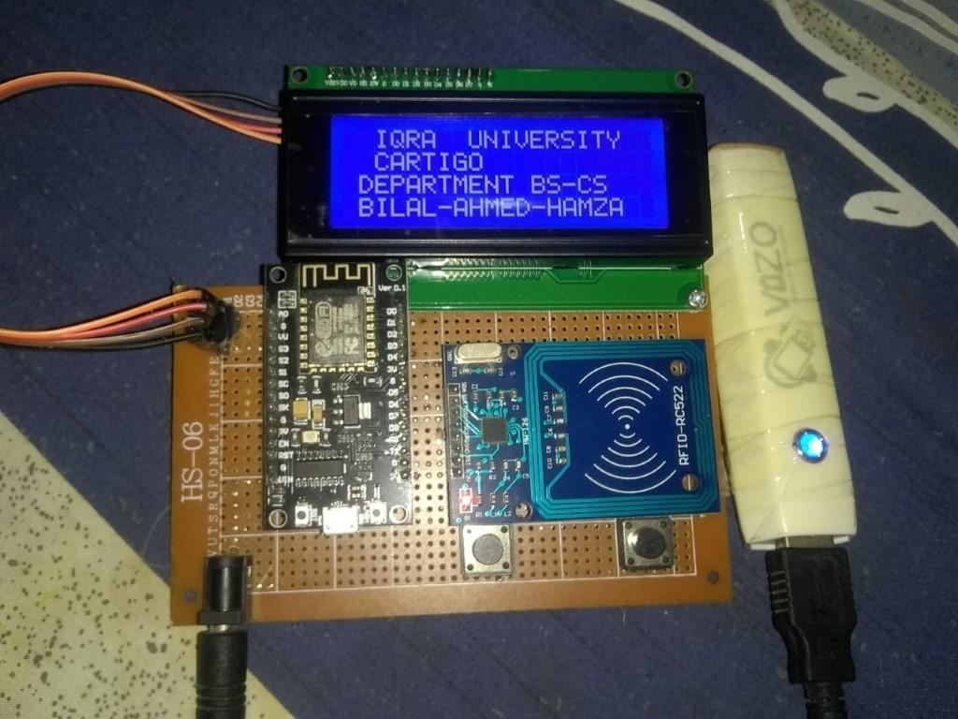 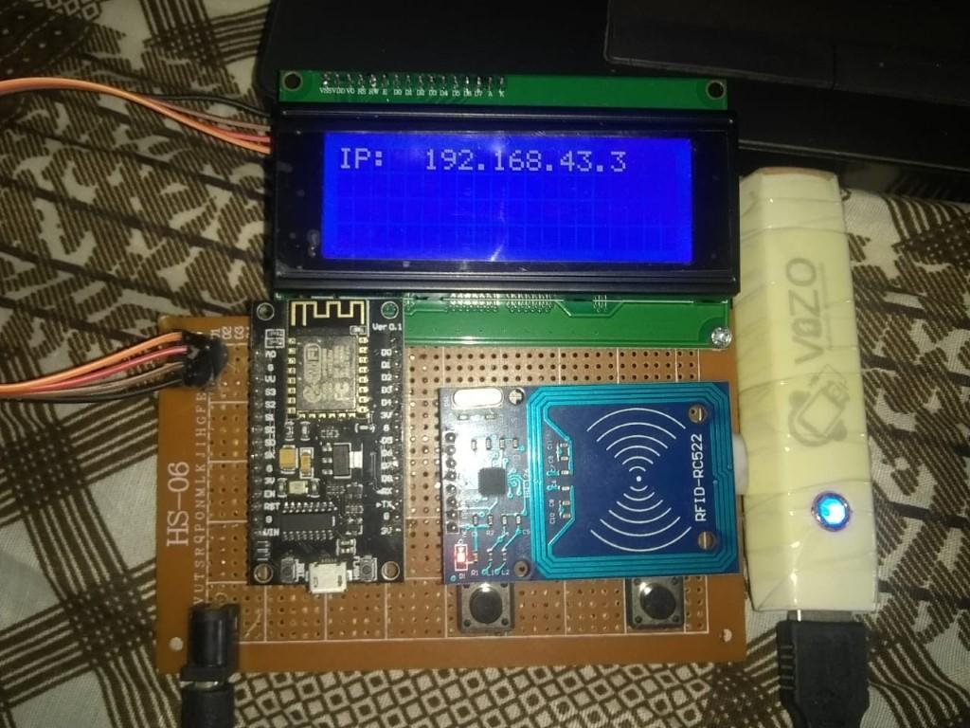

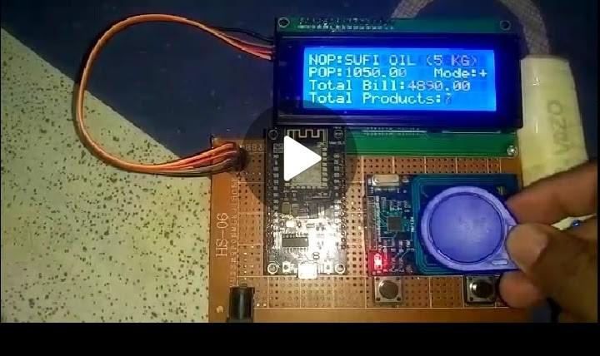 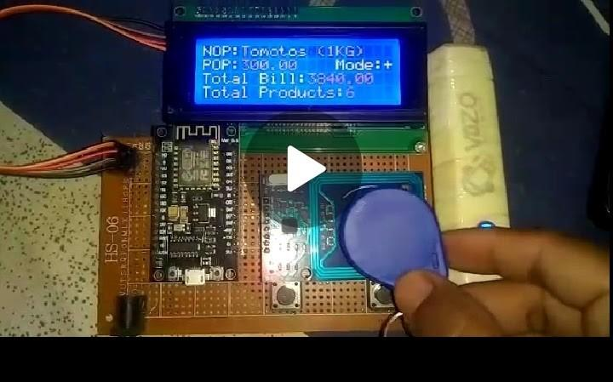

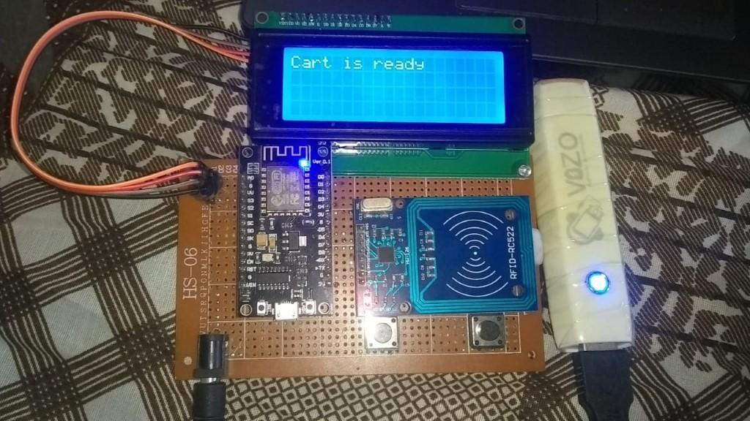 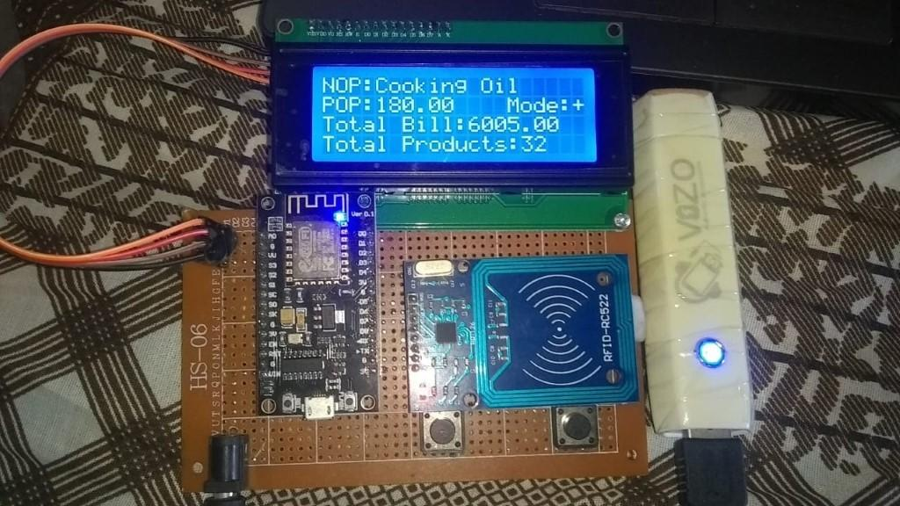

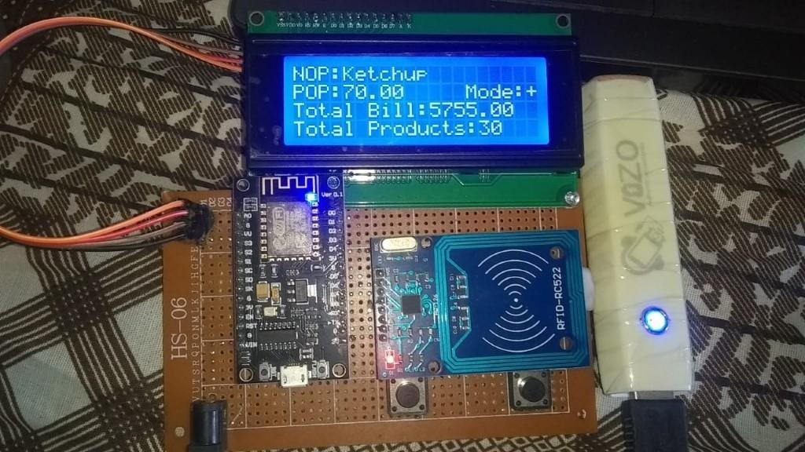 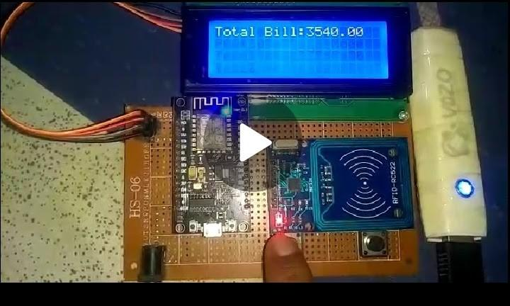

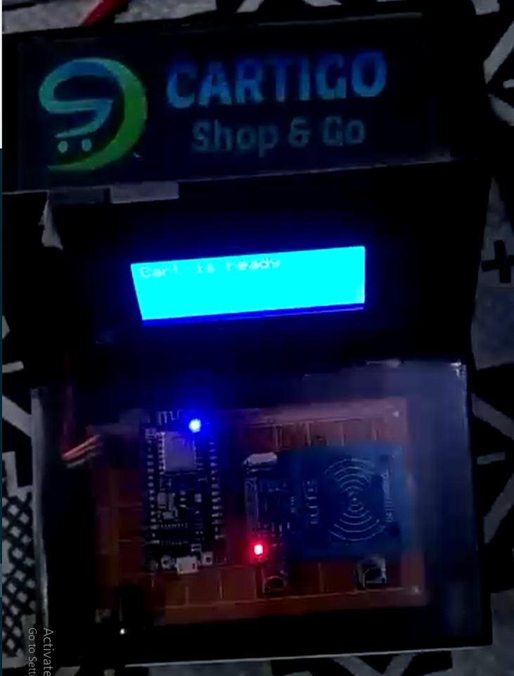 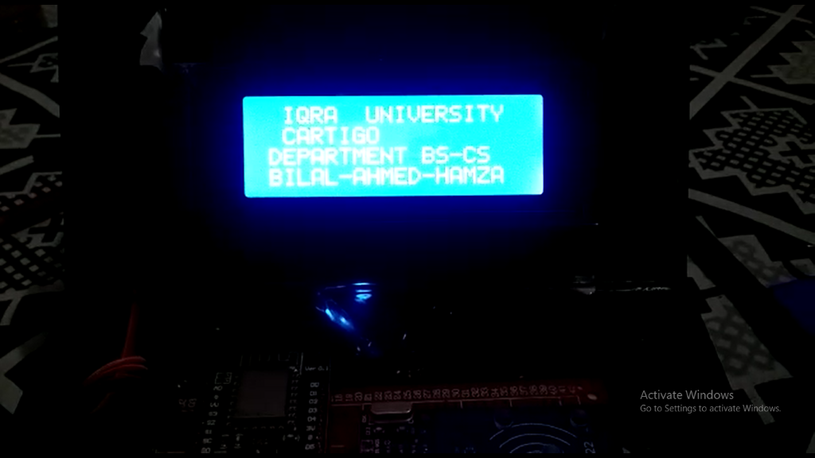

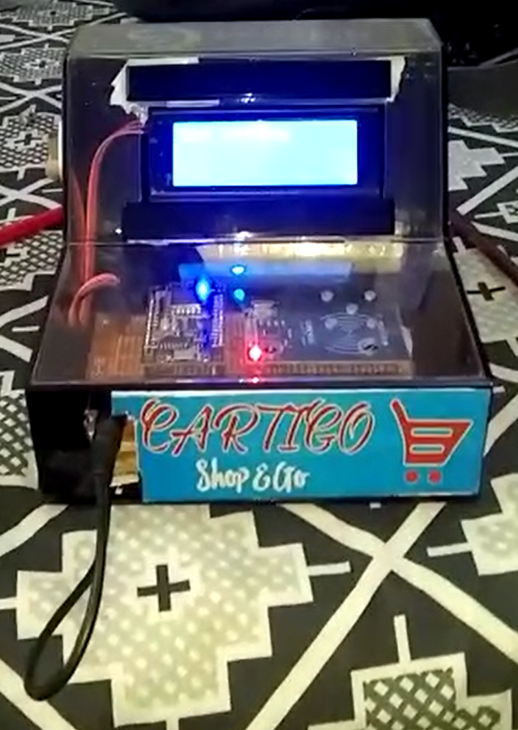 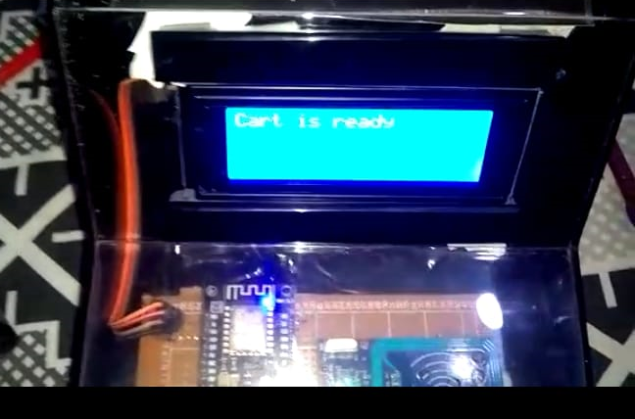

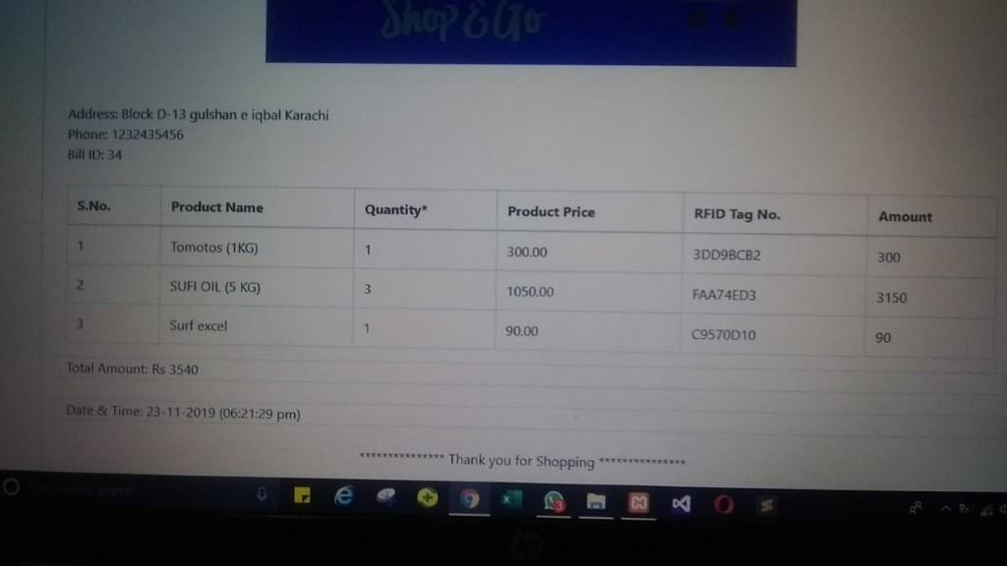

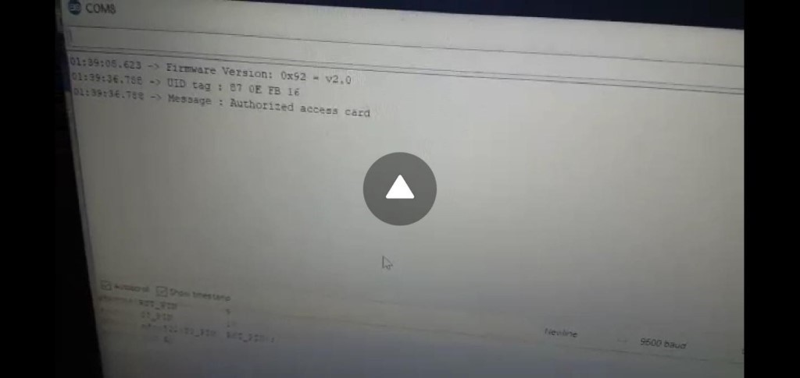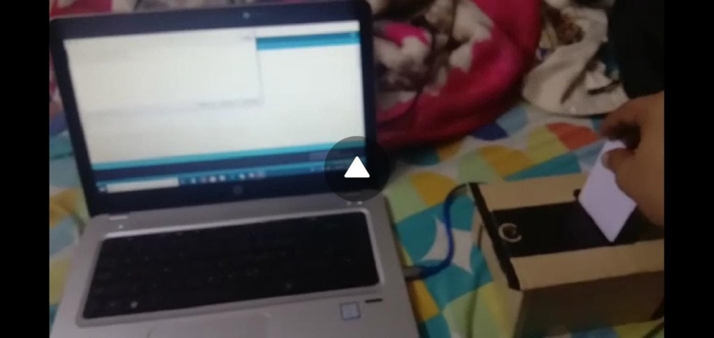

**------------------------------------------------------------------  
Chapter 6;**

**Test Cases**

**-----------------------------------------------------------------**

## Test Plan

**(Automatic Shopping Cart)**

**Purpose:**  
  
The test plan is created during the development or reverse engineering phase and identify all elements that are about to be tested. The test plan should explicitly describe what to test, what to expect, and how to do the testing. Subsequently it should be confirmed what was done, what was the result, and if the result was approved. The main purpose of writing this section is to test every feature of our project, including both the hardware, software aspects and security alarm system using RFID card access system and also performing different testing methodologies to test and check whether they are working optimally or not.

**Test objectives:**

* Finding problems which came up during the development process of the Cart Hardware.
* To test for Compatibility of the Different components of the Cart Hardware System and Security alarm and Web Based application.
* Gaining Confidence in and providing Information about the level of knowledge of the cart system.
* To Prevent surprise problems before rather than later in the Cart hardware system.
* To Ensure that the finished product met all the user requirements.
* To ensure that the Automatic Shopping Cart fulfill the system requirements specifications.
* To provide training and create confidence among the users of the Automatic Shopping Cart system by creating the impression that was tested and running successfully.
* To check the functionality of security alarm system using RFID card for authorized and Unauthorized access buzzer system

**Scope:**  
The purpose of this report is to find and fix bugs in the project in order to obtain user experience and make our project more effective and error-free. All application functionality has been checked to add products, upgrade products, uninstall items, scan products and search bills to the server feature. This included both the Cart Hardware software and the ASC Web-based program.

**Testing Methodologies:**

Software testing methodologies are the different approaches and ways of ensuring that a software application in particular is fully tested. Software testing methodologies encompass everything from unit testing individual modules, integration testing an entire system to specialized forms of testing such as security and performance. The purpose of developing these strategies is to ensure completeness when it comes to the project’s construction, that it includes all of the system features, is completed within the allotted timeline and budget, and allows for plans to scale the testing efforts even more. Testing strategy will affect test planning, test type, test script development, and test execution tasks.

* **Black Box Testing:**

Black box analysis, also known as behavioral, opaque-box, closed-box testing, is a test method that analyzes the usability of the software / application without knowing much about the internal structure / design of the object being evaluated and compares the input value to the output value. It is a technique which ignores the system's internal mechanism and focuses on the output produced.

* **White Box Testing:**

White Box Testing is a test of the internal coding and functionality of the software solution. It focuses primarily on enhancing security, the flow of inputs and outputs through application, and improving design and usability. White box testing is also known as Clear Box Testing, Open Box Testing, Structural Testing, Transparent Box Testing, Software Based Testing, and Glass Box Testing.

**Levels of Testing:**

Testing is the method of testing a code object to identify the variations between the input and the predicted output. Also, to determine the functionality of the computer object. Analysis measures the quality of the product. Software testing is a process that should be carried out during the development process. In other words, code testing is a method of verification and validation.

**Unit Testing:**

It includes testing different modules individually and ensuring the proper functioning of each module. Unit testing is a software testing method by which individual source code units, a set of one or more computer program modules, together with the associated control data, usage procedures and operating procedures, are tested to determine whether they are suitable for use.

**Modules Tested:**

* WIFI (hotspot) connectivity.
* Products scan function in the Hardware.
* Add product function in the Hardware.
* Remove Button function in the Hardware.
* Reset Button function in the Hardware.
* Send Bill function in the Hardware.
* Total amount function display in LCD.
* No# of products displays in LCD.
* Different Bill ID for each Bill.
* Bill Generated in the System.
* Security alarm Buzzer (authorized access/unauthorized access).

**Integration Testing:**

This involves testing two or more modules together to ensure the compatibility of the various modules. This is the software testing process in which single software modules are integrated and evaluated as a group. This occurs after device testing and validation testing. Integration testing shall be carried out as its unit-tested input components, grouped into larger aggregates, and tests shall be used to identify the component.

**Functional Testing:**

This type deals with the functional requirements or specifications of an application. By providing the input and comparing the actual output with the expected output, different actions or functions of the system are being tested here.

**Regression testing:**

Regression testing is the method of checking computer program improvements to ensure existing programming still functions with the new changes. It is done after software updates, improvements or any other system maintenance to verify that the current code has not been compromised.

**Hardware Testing:**

Hardware testing is conducted on a complete, integrated system to evaluate the system's compliance with its specified requirements. Each piece of hardware equipment is also individually tested to see if it works on its own.

**Performance Testing:**

Quality testing is the method of evaluating a system, network, software program or device's speed, responsiveness, and stability under a workload. Performance testing can require quantitative testing conducted in a laboratory or occur in specific scenarios in the production environment. Typical parameters include speed of transmission, data transfer frequency, network bandwidth, quality of work and reliability.

**Usability Testing:**

Usability testing is important to develop strategies for finding out how systems work practically when they are delivered to customers.

* Testing Application item like buttons, different tabs.
* Application should be easy to understand
* Instructions provided should be very clear to the end user.

**GUI Testing:**

Interaction between the various components of an application and the user will affect the product's overall efficiency, so this interaction, i.e. the software must also be checked and confirmed if there are no graphical bugs.

**Compatibility Testing:**

Compatibility Testing is a form of software testing to check if the code can run on different hardware, operating systems, applications, network environments or different devices. Compatibility testing is one form of non-functional testing.

**System Testing:**

It is a software test level which tests a complete and integrated software. The purpose of this test is to evaluate the system’s compliance with the specified requirements. This involves testing of the whole system. Here we tested whole Automatic Shopping Cart with web-based application and security alarm.

**Test Cases Factors:**

1. **Test Entry / Exit Criteria**

This sets out the parameters suggesting a successful completion of a test phase. The exit requirements are the test's expected outcomes, and are required before progressing to the next development phase. Example: it must pass 95 percent of all-important test cases. (LibStudies, n.d.)

1. **Test Deliverables**

Test Deliverables is a list of all the documents, software and other resources needed to be created and maintained to support the testing effort.

At each step of the software development lifecycle there are different test deliverables.

Test deliverables are provided **before** testing phase.

* Test plans document.
* Test cases documents
* Test Design specifications.

Test deliverables are provided **during** the testing

* Test Scripts
* Simulators.
* Test Data
* Test Traceability Matrix
* Error logs and execution logs.

After the test cycles are over, test deliverables are provided.

* Test Results/reports
* Defect Report
* Installation/ Test procedures guidelines
* Release notes

## Test Suspension / Resumption Criteria

Specify the criteria critical for a test suspension. If the criteria for the suspension are met during the test, the active test cycle will be suspended until the criteria have been resolved. For example, if our team members claim that 40 percent of test cases have failed, you will postpone testing until all the failed cases are resolved by the development team.

## Test Environmental / Staffing / Training Needs

A testing environment is a software and hardware system that the testing team must run test cases on. The research environment consists of real business environment and user etc.as well as physical environments such as server, front-end running environment.

## 

## 

## 

## 

## 

## Test Cases

**(Automatic Shopping Cart)**

**Unit Testing**

1. **Test Entry / Exit Criteria**

All of the components should be working for passing entry criteria. Exit criteria will only happen if the scenario passes tests.

1. **Test Deliverables**

Information about all of the main components or building blocks of the application and hardware.

1. **Test Cases / Scenarios**

* **Checking Connectivity WIFI (Hotspot)**

|  |  |  |  |  |  |
| --- | --- | --- | --- | --- | --- |
| **Step No.** | **Test Step** | **Test Data** | **Expected Result** | **Actual Result** | **Status (Pass/Fail)** |
| 1 | Node MCU Module | Assign SSID Username and Password | Device should connect | Hotspot connected | Pass |

* **Checking RFID Reader**

|  |  |  |  |  |  |
| --- | --- | --- | --- | --- | --- |
| **Step No.** | **Test Step** | **Test Data** | **Expected Result** | **Actual Result** | **Status (Pass/Fail)** |
| 1 | Scan the RFID Tags | RFID Tag | RFID Tags detail | RFID Tag Number | Pass |

* **Checking Products details of RFID tags Displayed in LCD**

|  |  |  |  |  |  |
| --- | --- | --- | --- | --- | --- |
| **Step No.** | **Test Step** | **Test Data** | **Expected Result** | **Actual Result** | **Status (Pass/Fail)** |
| 1 | Scan the RFID Tags | Product Name, Product Price, | Device should Display NOP, POP | Device should Display NOP, POP | Pass |

* **Checking Total Amount of Products Added Displayed in LCD**

|  |  |  |  |  |  |
| --- | --- | --- | --- | --- | --- |
| **Step No.** | **Test Step** | **Test Data** | **Expected Result** | **Actual Result** | **Status (Pass/Fail)** |
| 1 | Scan the RFID Tags | Adding Products | Device should Show Total Amount | Total Amount Displayed | Pass |

* **Checking Number of Products Displayed in LCD**

|  |  |  |  |  |  |
| --- | --- | --- | --- | --- | --- |
| **Step No.** | **Test Step** | **Test Data** | **Expected Result** | **Actual Result** | **Status (Pass/Fail)** |
| 1 | Scan the RFID Tags | No of Products | Device should Show No of Products | No of Products Displayed | Pass |

* **Checking Complete Working of Remove Button**

|  |  |  |  |  |  |
| --- | --- | --- | --- | --- | --- |
| **Step No.** | **Test Step** | **Test Data** | **Expected Result** | **Actual Result** | **Status (Pass/Fail)** |
| 1 | Press Remove button | Mode (Negative) | Device should Mode (-) on LCD | Mode (-) on LCD | Pass |
| 2 | Scan the RFID Tags | Mode (-) Product Name, Product price | Device should Remove Product | Remove Product from Device | Pass |

* **Checking Complete Working of ADD Button**

|  |  |  |  |  |  |
| --- | --- | --- | --- | --- | --- |
| **Step No.** | **Test Step** | **Test Data** | **Expected Result** | **Actual Result** | **Status (Pass/Fail)** |
| 1 | Press Remove button | Mode (Add) | Device should Mode (+) on LCD | Mode (+) on LCD | Pass |
| 2 | Scan the RFID Tags | Mode (+) Product Name, Product price | Device should ADD Product | ADD Product from Device | Pass |

* **Checking Complete Working of Total Bill Button**

|  |  |  |  |  |  |
| --- | --- | --- | --- | --- | --- |
| **Step No.** | **Test Step** | **Test Data** | **Expected Result** | **Actual Result** | **Status (Pass/Fail)** |
| 1 | Scan the RFID Tags with Product Detail | Product Name, Product Price | Device should Display NOP, POP | Device should Display NOP, POP | Pass |
|  |  |  |  |  |  |
| 2 | Adding Products | Product Name, Product Price | Device should Show Total Amount | Total Amount Displayed | Pass |  |
| 3 | Press Total Bill button | Total Bill | Device should Show Total Bill | Device should Show Total Bill | pass |

1. **Test Suspension / Resumption Criteria**

If any scenario fails, it will be suspended or sent for resumption or for retry.

1. **Test Environmental / Staffing / Training Needs**

Proper environment should be set up, PC, laptop should be up to date and bug free.

**Integration Testing**

1. **Test Entry / Exit Criteria**

All of the components should be working for passing entry criteria. Exit criteria will only happen if the scenario passes tests.

1. **Test Deliverables**

Information about the integration and communication of main components of the application and hardware.

1. **Test Cases / Scenarios**

* **Checking Complete Pairing of Devices**

|  |  |  |  |  |  |
| --- | --- | --- | --- | --- | --- |
| **Step No.** | **Test Step** | **Test Data** | **Expected Result** | **Actual Result** | **Status (Pass/Fail)** |
| 1 | Node MCU Module | Assign SSID Username and Password | Device should connect | Hotspot connected | Pass |
| 2 | Pairing with the module | Pairing local IP address | Pair should be successful | Devices paired | Pass |

|  |  |  |  |  |  |
| --- | --- | --- | --- | --- | --- |
| **Step No.** | **Test Step** | **Test Data** | **Expected Result** | **Actual Result** | **Status (Pass/Fail)** |
| 4 | Transferring commands to Node MCU | Commands sent via Node MCU ESP2866 connection | Node MCU ESP2866 should acknowledge command and act | Node MCU ESP2866 acts | Pass |

1. **Test Suspension / Resumption Criteria**

If any scenario fails, it will be suspended or sent for resumption or for retry.

1. **Test Environmental / Staffing / Training Needs**

Proper environment should be set up, PC, laptop should be up to date and bug free.

**Functional Testing**

1. **Test Entry / Exit Criteria**

All of the components should be working for passing entry criteria. Exit criteria will only happen if the scenario passes tests.

1. **Test Deliverables**

Information about all of the main components and the functionalities of the application and hardware.

1. **Test Cases / Scenarios**

* **Checking Functionality of Node MCU ESP8266 With Web Page**

|  |  |  |  |  |  |
| --- | --- | --- | --- | --- | --- |
| **Step No.** | **Test Step** | **Test Data** | **Expected Result** | **Actual Result** | **Status (Pass/Fail)** |
| 1 | Connecting Web page with NodeMCU via Esp2866 | WIFI module and signals | WIFI should connect devices | Devices Paired | Pass |
| 2 | Signals send via Web Page | Node MCU should recognize Local host IP address | Commands should execute by RFID Reader | Command executed properly | Pass |

* **Checking failed Functionality of Bluetooth Command Recognition**

|  |  |  |  |  |  |
| --- | --- | --- | --- | --- | --- |
| **Step No.** | **Test Step** | **Test Data** | **Expected Result** | **Actual Result** | **Status (Pass/Fail)** |
| 1 | Connecting Web page with NodeMCU via Esp2866 | WIFI module and signals | WIFI should connect devices | Devices Not Paired | Fail |
| 2 | Signals send via Web Page | Node MCU should recognize Local host IP address | Commands should execute by RFID Reader | Command not executed properly | Fail |

1. **Test Suspension / Resumption Criteria**

If any scenario fails, it will be suspended or sent for resumption or for retry

1. **Test Environmental / Staffing / Training Needs**

Proper environment should be set up, PC, laptop should be up to date and bug free

**Regression testing**

1. **Test Entry / Exit Criteria**

All of the components should be working for passing entry criteria. Exit criteria will only happen if the scenario passes tests.

1. **Test Deliverables**

Information about all of the main components their updates and condition after the upgrades.

1. **Test Cases / Scenarios**

* **Testing Device After Upgrading Battery/ Power Bank**

|  |  |  |  |  |  |
| --- | --- | --- | --- | --- | --- |
| **Step No.** | **Test Step** | **Test Data** | **Expected Result** | **Actual Result** | **Status (Pass/Fail)** |
| 1 | Replacing the 7V battery with a higher capacity 5V one | Re-establishing connections via the wires | Node MCU should power up | LED powers up | Pass |
| 2 | Battery should give a longer duration of function | High capacity of battery | The hardware should stay powered up for longer | The hardware endures for longer | Pass |

1. **Test Suspension / Resumption Criteria**

If any scenario fails, it will be suspended or sent for resumption or for retry

1. **Test Environmental / Staffing / Training Needs**

Proper environment should be set up, PC, laptop should be up to date and bug free. Safety measures should be taken as we are dealing with hardware.

**Hardware Testing**

1. **Test Entry / Exit Criteria**

All of the components should be working for passing entry criteria. Exit criteria will only happen if the scenario passes tests.

1. **Test Deliverables**

Information about all of the main hardware components and their condition.

1. **Test Cases / Scenarios**

* **Testing Device Connection via Wires**

|  |  |  |  |  |  |
| --- | --- | --- | --- | --- | --- |
| **Step No.** | **Test Step** | **Test Data** | **Expected Result** | **Actual Result** | **Status (Pass/Fail)** |
| 1 | Powering up the Node MCU via battery/ power Bank | Establishing connections to the Node MCU via Soldering with Wire | Node MCU LED should power up | LED power ups | Pass |

* **Checking Connectivity WIFI (Hotspot)**

|  |  |  |  |  |  |
| --- | --- | --- | --- | --- | --- |
| **Step No.** | **Test Step** | **Test Data** | **Expected Result** | **Actual Result** | **Status (Pass/Fail)** |
| 1 | Node MCU Module | Assign SSID Username and Password | Device should connect | Hotspot connected | Pass |

* **Checking RFID Reader**

|  |  |  |  |  |  |
| --- | --- | --- | --- | --- | --- |
| **Step No.** | **Test Step** | **Test Data** | **Expected Result** | **Actual Result** | **Status (Pass/Fail)** |
| 1 | Scan the RFID Tags | RFID Tag | RFID Tags detail | RFID Tag Number | Pass |

* **Testing Node MCU Code Uploading**

|  |  |  |  |  |  |
| --- | --- | --- | --- | --- | --- |
| **Step No.** | **Test Step** | **Test Data** | **Expected Result** | **Actual Result** | **Status (Pass/Fail)** |
| 1 | Powering up Node MCU | Establishing connections to the Node MCU via wires | Node MCUs LED should power up | LED power ups | Pass |
| 2 | Connecting the Node MCU with a laptop via USB cable | USB ports and cable | The laptop should recognize Node MCU | Node MCU recognized | Pass |
| 3 | Using the Arduino IDE to interact with the board | Uploaded code to the Arduino IDE | Code should be uploaded to the  Arduino IDE | Code uploaded | Pass |
| 4 | Checking functionality of uploaded code | Commands sent to the Arduino to check uploaded code | Node MCU should perform its programmed functionalities | Functionalities performed | Pass |

|  |  |  |  |  |  |
| --- | --- | --- | --- | --- | --- |
| **Step No.** | **Test Step** | **Test Data** | **Expected Result** | **Actual Result** | **Status (Pass/Fail)** |
| 1 | Connecting RFID Reader to a preprogrammed Node MCU with an LED | Connecting the RFID Reader to via wires | RFID Reader should be connected properly | RFID Reader connected | Pass |

* **Testing Battery Rating**

|  |  |  |  |  |  |
| --- | --- | --- | --- | --- | --- |
| **Step No.** | **Test Step** | **Test Data** | **Expected Result** | **Actual Result** | **Status (Pass/Fail)** |
| 1 | Using a multimeter to measure specification of battery | Battery | The voltage and ampere rating of battery should be revealed(5V) | Specifications are revealed completely | Pass |

1. **Test Suspension / Resumption Criteria**

If any scenario fails, it will be suspended or sent for resumption or for retry

1. **Test Environmental / Staffing / Training Needs**

Safety measures should be taken as we are dealing with hardware.

**Performance Testing**

1. **Test Entry / Exit Criteria**

All of the components should be working for passing entry criteria. Exit criteria will only happen if the scenario passes tests.

1. **Test Deliverables**

Information about responsiveness and load bearing capabilities of the application and hardware.

1. **Test Cases / Scenario**

* **Testing Load Time for Login Web Page:**

|  |  |  |  |  |  |
| --- | --- | --- | --- | --- | --- |
| **Step No.** | **Test Step** | **Test Data** | **Expected Result** | **Actual Result** | **Status (Pass/Fail)** |
| 1 | Launching web page | (CARTIGO)login page with username and password | login web page should launch | login web page launches | Pass |
| 2 | Measuring time taken for application to launch | Time taken to load | Web page should launch faster | The launch is fast | Pass |

* **Testing for Username and Password is Valid:**

|  |  |  |  |  |  |
| --- | --- | --- | --- | --- | --- |
| **Step No.** | **Test Step** | **Test Data** | **Expected Result** | **Actual Result** | **Status (Pass/Fail)** |
| 1 | enter a valid username and password in the login page | username and password | logged in to Homepage | login to Homepage | Pass |

**Testing for Username and Password is not valid:**

|  |  |  |  |  |  |
| --- | --- | --- | --- | --- | --- |
| **Step No.** | **Test Step** | **Test Data** | **Expected Result** | **Actual Result** | **Status (Pass/Fail)** |
| 1 | enter incorrect username and password in the login page | username and password | Redirect to Login page | Redirect to Login page | Pass |

* **Testing add products to Database:**

|  |  |  |  |  |  |
| --- | --- | --- | --- | --- | --- |
| **Step No.** | **Test Step** | **Test Data** | **Expected Result** | **Actual Result** | **Status (Pass/Fail)** |
| 1 | Navigate to Add product from Homepage | add new products | display add product box | add product box displayed | Pass |
| 2 | Enter RFID, Name, price | RFID, Name and Price | product should be added to database | product added to Database | Pass |

* **Testing Update products to Database:**

|  |  |  |  |  |  |
| --- | --- | --- | --- | --- | --- |
| **Step No.** | **Test Step** | **Test Data** | **Expected Result** | **Actual Result** | **Status (Pass/Fail)** |
| 1 | Navigate to Add product from Homepage | update products | display update product box | update product box displayed | Pass |
| 2 | Update RFID, Name, price | RFID, Name and Price | product should be Updated to database | product Updated to Database | Pass |

* **Testing Delete products from Database:**

|  |  |  |  |  |  |
| --- | --- | --- | --- | --- | --- |
| **Step No.** | **Test Step** | **Test Data** | **Expected Result** | **Actual Result** | **Status (Pass/Fail)** |
| 1 | Navigate to Add product from Homepage | delete products | product should be deleted from database | product deleted | Pass |

* **Testing search products through ID from Database:**

|  |  |  |  |  |  |
| --- | --- | --- | --- | --- | --- |
| **Step No.** | **Test Step** | **Test Data** | **Expected Result** | **Actual Result** | **Status (Pass/Fail)** |
| 1 | Navigate to Search product from Homepage | product ID | display product information | Products information displayed | Pass |

* **Testing Searching Bill through ID from Database:**

|  |  |  |  |  |  |
| --- | --- | --- | --- | --- | --- |
| **Step No.** | **Test Step** | **Test Data** | **Expected Result** | **Actual Result** | **Status (Pass/Fail)** |
| 1 | Navigate to Search Bill from Homepage | Bill ID | display ID and amount of Bill | Bill ID and amount displayed | Pass |

* **Testing Get Bill with Bill ID from via total bill Button in Hardware:**

|  |  |  |  |  |  |
| --- | --- | --- | --- | --- | --- |
| **Step No.** | **Test Step** | **Test Data** | **Expected Result** | **Actual Result** | **Status (Pass/Fail)** |
| 1 | Navigate to get Bill from Homepage | bill ID, total amount, time/date | should display bill format | Bill displayed | Pass |

1. **Test Suspension / Resumption Criteria**

If any scenario fails, it will be suspended or sent for resumption or for retry

1. **Test Environmental / Staffing / Training Needs**

Proper environment should be set up, PC, laptop or smartphone should be up to date and bug free. Safety measures should be taken as we are dealing with hardware.

**Usability Testing**

1. **Test Entry / Exit Criteria**

All of the components should be working for passing entry criteria. Exit criteria will only happen if the scenario passes tests.

1. **Test Deliverables**

Information on how it is easy for a user to use the application and hardware.

1. **Test Cases / Scenarios**

* **Checking Apparel of Navigation of web page:**

|  |  |  |  |  |  |
| --- | --- | --- | --- | --- | --- |
| **Step No.** | **Test Step** | **Test Data** | **Expected Result** | **Actual Result** | **Status (Pass/Fail)** |
| 1 | Checking Interface of web page | Login, Navigation tab and buttons on webpage | It should be easy to understand | Interface is simple | Pass |

* **Checking Apparel of Navigation pages:**

|  |  |  |  |  |  |
| --- | --- | --- | --- | --- | --- |
| **Step No.** | **Test Step** | **Test Data** | **Expected Result** | **Actual Result** | **Status (Pass/Fail)** |
| 1 | Checking Navigation of pages on web page | Text used on buttons or tabs | Text should be plenty and not obscured | Text are clear to understand | Pass |

* **Checking Relevancy of Information**

|  |  |  |  |  |  |
| --- | --- | --- | --- | --- | --- |
| **Step No.** | **Test Step** | **Test Data** | **Expected Result** | **Actual Result** | **Status (Pass/Fail)** |
| 1 | Webpage having data from database in search product and search Bill | product details and bill details | Application should show relevant information | Information is relevant | Pass |

1. **Test Suspension / Resumption Criteria**

If any scenario fails, it will be suspended or sent for resumption or for retry

1. **Test Environmental / Staffing / Training Needs**

Proper environment should be set up, PC, laptop or smartphone should be up to date and bug free.

**GUI Testing:**

1. **Test Entry / Exit Criteria**

All of the components should be working for passing entry criteria. Exit criteria will only happen if the scenario passes tests.

1. **Test Deliverables**

Information about the interface, design and style of the application.

1. **Test Cases / Scenarios**

* **Checking Alignment of Elements**

|  |  |  |  |  |  |
| --- | --- | --- | --- | --- | --- |
| **Step No.** | **Test Step** | **Test Data** | **Expected Result** | **Actual Result** | **Status (Pass/Fail)** |
| 1 | Checking Alignment of buttons | Buttons on pages | Buttons should be of same size and alignment | Buttons are properly aligned | Pass |

* **Checking Alignment of tabs**

|  |  |  |  |  |  |
| --- | --- | --- | --- | --- | --- |
| **Step No.** | **Test Step** | **Test Data** | **Expected Result** | **Actual Result** | **Status (Pass/Fail)** |
| 1 | Checking Alignment of tabs | tabs on Homepage, search and search Bill | tabs should be of same size and alignment | Tabs are properly aligned | Pass |
|  |  |  |  |  |  |

* **Checking Visibility of Elements**

|  |  |  |  |  |  |
| --- | --- | --- | --- | --- | --- |
| **Step No.** | **Test Step** | **Test Data** | **Expected Result** | **Actual Result** | **Status (Pass/Fail)** |
| 1 | Checking Visibility of buttons | login, homepage, search products, search bill | Buttons should be clear | Buttons are properly visible | Pass |
|  |  |  |  |  |  |

* **Checking Visibility of Elements**

|  |  |  |  |  |  |
| --- | --- | --- | --- | --- | --- |
| **Step No.** | **Test Step** | **Test Data** | **Expected Result** | **Actual Result** | **Status (Pass/Fail)** |
| 1 | Checking text display of tabs used for switching screens | Tabs on the bottom and top of the application | text tabs should be clear and appropriate | tabs are proper | Pass |
|  |  |  |  |  |  |

1. **Test Suspension / Resumption Criteria**

If any scenario fails, it will be suspended or sent for resumption or for retry

1. **Test Environmental / Staffing / Training Needs**

Proper environment should be set up, PC, laptop or smartphone should be up to date and bug free.

**Compatibility Testing**

1. **Test Entry / Exit Criteria**

All of the components should be working for passing entry criteria. Exit criteria will only happen if the scenario passes tests.

1. **Test Deliverables**

Information regarding the devices that can support the application and hardware.

1. **Test Cases / Scenarios**

* **Testing Application working and failure on Various Devices**

|  |  |  |  |  |  |
| --- | --- | --- | --- | --- | --- |
| **Step No.** | **Test Step** | **Test Data** | **Expected Result** | **Actual Result** | **Status (Pass/Fail)** |
| 1 | Open webpage on Google chrome | Login form | Google chrome should run without trouble | Login form  Displays  Application runs | Pass |

|  |  |  |  |  |  |
| --- | --- | --- | --- | --- | --- |
| **Step No.** | **Test Step** | **Test Data** | **Expected Result** | **Actual Result** | **Status (Pass/Fail)** |
| 1 | Open webpage on Internet explorer | Login form | Internet explorer should run without trouble | Login form  Displays  Application runs | Pass |

* **Checking Working Slow and Success**

|  |  |  |  |  |  |
| --- | --- | --- | --- | --- | --- |
| **Step No.** | **Test Step** | **Test Data** | **Expected Result** | **Actual Result** | **Status (Pass/Fail)** |
| 1 | Open webpage on Opera Mini | Login form | Google chrome should run without trouble | Login form  Displays  Application runs slowly | Pass |

1. **Test Suspension / Resumption Criteria**

If any scenario fails, it will be suspended or sent for resumption or for retry

1. **Test Environmental / Staffing / Training Needs**

Proper environment should be set up, PC, laptop or smartphone should be up to date and bug free. Safety measures should be taken as we are dealing with hardware.

**System Testing**

1. **Test Entry / Exit Criteria**

All of the components should be working for passing entry criteria. Exit criteria will only happen if the scenario passes tests.

1. **Test Deliverables**

Information about all of the main components working together as an end product.

1. **Test Cases / Scenarios**

* **Checking Overall Navigation**

|  |  |  |  |  |  |
| --- | --- | --- | --- | --- | --- |
| **Step No.** | **Test Step** | **Test Data** | **Expected Result** | **Actual Result** | **Status (Pass/Fail)** |
| 1 | login to Webpage | logo image on Home-screen | Web Page should load without any issues | loads successfully | Pass |
| 2 | Navigating through screens | Symbols/text or tabs for all three interfaces | Navigation should be without any issue | Navigation is successful | Pass |
| 3 | adding products | product name and price and RFID tags | should add products | products added | Pass |
| 4 | update products | product name and price and RFID tags | should update products | products updated | Pass |
| 5 | delete products | product name and price and RFID tags | product deleted | products deleted | Pass |
| 6 | search products | product ID | should display product information | products information displayed | Pass |
| 7 | Search Bill ID | Bill ID | should display bill information | Bill ID and amount displayed | Pass |
| 8 | get Bill | get bill with products, price and quantity and RFID tags | should print bill format | print bill format | Pass |
| 9 | Logout | Logout button | should logout from webpage | logged out from webpage | Pass |

* **Checking Software and Hardware Reliability**

|  |  |  |  |  |  |
| --- | --- | --- | --- | --- | --- |
| **Step No.** | **Test Step** | **Test Data** | **Expected Result** | **Actual Result** | **Status (Pass/Fail)** |
| 1 | Loading webpage with hardware in another device | Login form and connectivity with Hardware | webpage and Hardware should connect without any issues | connectivities problems | Fail |

* **Checking overall Status of components**

|  |  |  |  |  |  |
| --- | --- | --- | --- | --- | --- |
| **Step No.** | **Test Step** | **Test Data** | **Expected Result** | **Actual Result** | **Status (Pass/Fail)** |
| 1 | Supplying power to the Automatic Shopping Cart via power bank | Connecting the power bank to the hardware | Hardware should power up | Hardware powers up | Pass |
| 2 | Checking supply to Cart | LED on of ASC Cart | LED should light up | LED lights up | Pass |
| 3 | Checking supply to Node MCU | LED on of WIFI node MCU module | LED should light up | LED lights up | Pass |
| 4 | Checking status of adding products to Cart | scanning the products to add | products should be added by scanning | Products added to Cart | Pass |
| 5 | Checking status of removing products to Cart | press the remove button then scan products | product name and price should be reduced accordingly | Product and product prices are reduced from the amount and cart | Pass |
| 6 | Checking status of total bill to the Cart | products, price quantity, total amount and Bill ID | get the print bill with bill ID accordingly | print bill with Bill id and products | Pass |

**RFID Security Alarm System:**

**Hardware Testing:**

1. **Test Entry / Exit Criteria**

All of the components should be working for passing entry criteria. Exit criteria will only happen if the scenario passes tests.

1. **Test Deliverables**

Information about all of the main hardware components and their condition.

1. **Test Cases / Scenarios**

* **Checking security alarm system working (Idea):**

|  |  |  |  |  |  |
| --- | --- | --- | --- | --- | --- |
| **Step No.** | **Test Step** | **Test Data** | **Expected Result** | **Actual Result** | **Status (Pass/Fail)** |
| 1 | Connecting the USB cable connection | Connecting the USB cable to the hardware | Hardware should power up | Hardware powers up | Pass |
| 2 | Checking Arduino IDE port connection | connect with port which will let LED & Buzzer on | LED should light up and buzzer initialize | LED light up and Buzzer initializes | Passl |
| 3 | Giving RFID Card authorized Number are in the program | RFID Number Access | RFID number given in authorize access should run on authorize condition accordingly | Buzzer run in authorize conditions applies | Pass |
| 4 | Giving RFID Card Unauthorized Number that are not in the program | RFID Unauthorized Card | RFID number has no access should run on Unauthorize condition accordingly | Buzzer runs in Unauthorize condition applies | Pass |

* **Checking Overall Security Alarm System (Idea);**

|  |  |  |  |  |  |
| --- | --- | --- | --- | --- | --- |
| **Step No.** | **Test Step** | **Test Data** | **Expected Result** | **Actual Result** | **Status (Pass/Fail)** |
| 1 | Connecting the USB cable connection | Connecting the USB cable to the hardware | Hardware should power up | Hardware should power up | Pass |
| 2 | Checking Arduino IDE port connection | connect with port which will let LED & Buzzer on | LED should light up and buzzer initialize | LED light up and Buzzer initializes | Passl |
| 3 | Verifying the Bill | Bill with Bill ID and products | Bill should have the products added in the cart | Bill with associated cart products have authorize card | Pass |
| 4 | Driving Cart through the person given Card should be scan in hardware | Authorized access | Buzzer will buzz normal | Buzzer buzz 2(low) and message: access | Pass |
| 5 | Driving Cart through the person given Card should be scan in hardware | Unauthorized access | Buzzer will not buzz normal | Buzzer buzz 3(HIGH)and alert message (not-  access | Pass |
| 6 | Driving Cart through the person can scan any RFID Card in hardware | Unauthorized access | Buzzer will not buzz normal | Buzzer buzz 3(HIGH)and alert message (not-  acces) | Pass |
| 7 | ARduino IDE is connected with Hardware | Arduino IDE, Port, Serial Monitor | System connected and Buzzer should run when Card scanned alert message generated in arduino IDE | System connected and Buzzer run when Card scanned and alert message generated in arduino IDE | Pass |

**----------------------------------------------------------------**

**Chapter 7;**

**Conclusion and Future Work:**

**-----------------------------------------------------------------**

**CONCLUSION:**

This proposed system works on improving customer satisfaction as on customer enter the supermart first customers take a cart which has a Cart ID number, Cart have hardware application with an RFID reader with Node MCU and LCD. Customer wants to add products in the Cart by scanning tags of the product that will be read by the reader. If the Tags matches with the product ID, then the cost of that product will be displayed on the LCD in the Cart. If the customer wants to remove product from the cart, the customer can take away that product from Cart and scanned again and cost of that product will be reduced from the total amount, and after shopping the products data with total amount gets transferred to the CBU through ESP-8266. The database at the central billing system will be updated when add/remove from the cart. And at the end the customer sends the data by pressing the send button on hardware, which generate the bill associated with trolley Cart ID. The cashier will verify Cart ID and customer will pay the bill without hectic of queues.

* **Good things:**
* A potential solution to the problem was built.
* Basic Solution for the cashier was also built.
* Most of the issues with RFID based totaling were resolved.

* **The following things could be done in future to improve project:**
* Integration with a real super mart.
* if you have addressed real hardware design issues.
* If you have conducted a survey with supermarts to discuss the issues with your solution.
* If you have solved the issue of theft and reduce the risk factors.
* If you have solved the issue of transferring data from the cart to a cashier where there is more than one cashier.
* If you have integrated your system with a real-life system.